

PLEASANT TOURS

E-project Report

GroupMember

|  |  |  |  |
| --- | --- | --- | --- |
| ***S.No*** | ***Student Id*** |  | ***Student Name*** |
| ***1*** | **990202** |  | ***Muhammad Humayun*** |
| ***2*** |  |  | ***Waqar Arif*** |
| ***3*** |  |  | ***Osama Amin*** |

**Project Advisor**

**NAZISH SATTAR**



*Aptech Computer Education*

*Korangi Center*

***ACKNOWLEDMENT***

***First of all we would like to thank ALLAH the almighty who make us able to complete this project.***

*After that we would like to express profound gratitude to our internal project advisor, Center Faculty Head,* ***MISS NAZISH,*** *for his precious support, back-up, supervision and useful suggestions throughout this project. His moral support and continuous help enabled us to complete our work successfully. We are also highly thankful to the Center Management for their valuable suggestions, healthy analysis and support throughout this project.*

*We are grateful to the faculty members of Aptech Korangi Center who were always there to help us despite oftheir personal workload*

* ***NAME OF MEMBER 1: MUHAMMAD HUMAYUN***
* ***NAME OF MEMBER 2: WAQAR ARIF***
* ***NAME OF MEMBER 3: OSAMA AMIN***

***TABLE OF CONTENT***

1 E-Project Synopsis 6

2 Introduction 6

3 Requirement Specification: 6

**4** **Technology Used** 7

5 Website Features 8

6 Site Requirement 8

7 E-Project Design 9

8 Header 9

9 Website structure 9

10 Home Page Layout 9

11 STARTING OF “HOME PAGE” 9

12 SCREEN SHOT OF “HOME PAGE” 23

13 STARTING OF “About Us PAGE” 24

14 SCREEN SHOT OF “ABOUT US PAGE” 35

15 STARTING OF “TOURS PAGE” 36

16 SCREEN SHOT OF “TOURS PAGE” 50

17 STARTING OF “BEACH TOUR PAGE” 52

18 SCREEN SHOT OF “BEACH TOUR PAGE” 61

19 STARTING OF “Hill Stations PAGE” 62

20 SCREEN SHOT OF “Hill Stations PAGE” 71

21 STARTING OF “Fort/Palaces PAGE” 72

22 SCREEN SHOT OF “Fort/Palaces PAGE” 81

23 STARTING OF “South America PAGE” 83

24 SCREEN SHOT OF “South America PAGE” 91

25 STARTING OF “Australia PAGE” 92

26 SCREEN SHOT OF “Australia PAGE” 100

27 STARTING OF “Africa PAGE” 101

28 SCREEN SHOT OF “Africa PAGE” 110

110

29 STARTING OF “EUROPE PAGE” 111

30 SCREEN SHOT OF “EUROPE PAGE” 119

31 STARTING OF “ASIA PAGE” 120

32 SCREEN SHOT OF “ASIA PAGE” 128

33 STARTING OF “GALLERY PAGE” 129

34 SCREEN SHOT OF “GALLERY PAGE” 146

35 STARTING OF “CONTACT US PAGE” 147

36 SCREEN SHOT OF “CONTACT US PAGE” 156

37 STARTING OF “LOGIN PAGE” 157

38 SCREEN SHOT OF “LOGIN PAGE” 166

39 STARTING OF “LOGIN SUB PAGE 1” 167

40 SCREEN SHOT OF “LOGIN SUB PAGE 1” 169

41 STARTING OF “LOGIN SUB PAGE 2” 170

42 END OF “LOGIN SUB PAGE 2” 172

SCREEN SHOT OF “LOGIN SUB PAGE 172

43 STARTING OF “LOGIN SUB PAGE 3” 173

44 SCREEN SHOT OF “LOGIN SUB PAGE 3” 175

# E-Project Synopsis

# Introduction

Pleasant Tours is into selling various tour products. They have predefined tours withitineraries. The company advertises by distributing the pamphlets, advertising ontelevision and so on. Due to rapid development in internet field, the companydecides to launch a website where people will get all the information about the various tour products available with them easily.

# Requirement Specification:

* The Home Page should be created making use of Frames with a suitable logo
* The site should display a menu which will contain the options for brief introduction about the various products available, location of the shop and any other information if required.
* The information should be categorized according to different type of products like if a User wants to see only ‘Beach Tours’ then he click on a Link/button/menu etc and he will see different type of Beach Tours. Similarly for ‘Hill Stations’, ‘Forts/Palaces’ and other products
* When a user selects any product type, a list of products for that product type will be displayed.
* Itinerary of individual tour products should be displayed on the Web Page along with the title but detailed itinerary should be stored in Individual Word documents which can be downloaded or viewed by the User who wishes to see the same.
* Price List for all tours should be available for download.
* There should be a “Contact Us” page which will have the Address of the Company which is as follows and the mail address which when clicked will invoke the local mail client from where they can send an email.

# **Technology Used**

*In order to meet the requirement of our project we have used following underlying technologies.*

* ***HTML5***
* ***CSS3***
* ***JAVASCRIPT***



# Website Features

* *We have used Html5.*
* *Color combination is according to Logo.*
* *Result section have been made in such a way that user can search his result by any search parameter*

# Site Requirement

*Since we have used HTML, CSS and JAVASCRIPT it might have certain compatibility issues. We used the latest version of the framework and yet it has certain limitation. We highly recommend this website to be opened on “Google Chrome” due the best compatibility available.[5]*

|  |  |  |  |  |
| --- | --- | --- | --- | --- |
| ***Chrome*** | ***Firefox*** | ***Internet Explorer*** | ***Opera*** | ***Safari*** |
| * *Supported* | * *Supported* | *N/A* | * *Not Supported* | *N/A* |
| * *Supported* | *Supported* | *N/A* | * *Not Supported* | * *Supported* |
| * *Supported* | * *Supported* | *N/A* | * *Supported* | * *Supported* |
| * *Supported* | * *Supported* | * *Supported* | * *Supported* | * *Not Supported* |

# E-Project Design

# Header

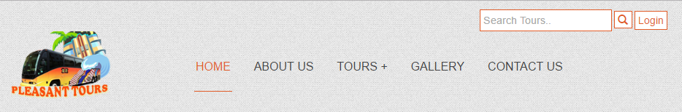

# Website structure

# Home Page Layout

# STARTING OF “HOME PAGE”

<!doctype html>

<html>

<head>

<meta charset="utf-8">

<link rel="shortcut icon" href="img/favicon.ico">

<meta name="viewport" content="width=device-width, initial-scale=1, maximum-scale=1, , initial-scale=1.0">

<link rel="stylesheet" href="css/main_style.css">

<link rel="stylesheet" href="css/bootstrap.min.css">

<link rel="stylesheet" href="css/font-awesome.css">

<link rel="stylesheet" href="css/font-awesome.min.css">

<link rel="stylesheet" href="css/animate.css">

<link href="css/jquery-accordion-menu.css" rel="stylesheet" type="text/css" />

<link href="css/jquery-ui.css" rel="stylesheet" type="text/css" />

<link rel="stylesheet" type="text/css" href="engine1/style.css" />

<script type="text/javascript" src="engine1/jquery.js"></script>

<title>PleasantTours</title>

</head>

<body>

<div id="totop"></div>

<div class="login-btn text-right">

<div class="container">

<input type="search" placeholder="Search Tours.." class="tour-btn">

<a href="tour.html">

<span class="glyphicon glyphicon-search tour-btn search"></span>

</a>

<a href="admin.html" class="tour-btn">Login</a>

</div>

</div>

<header class="zind">

<div class="container">

<div class="col-xs-4 col-md-3">

<a href="">

<img src="img/logo.png" alt="">

</a>

</div>

<div class="col-xs-8 col-md-9">

<div id="fdw">

<!--nav-->

<nav>

<ul>

<li class="current">

<a href="index.html">home</a>

</li>

<li><a href="about.html">about us</a></li>

<li>

<a href="tour.html">Tours +<span class="arrow"></span></a>

<ul style="display: none;" class="sub_menu">

<li class="arrow_top"></li>

<li><a href="beach.html">BEACH TOUR</a></li>

<li><a href="hill.html">Hill Stations</a></li>

<li><a href="fort.html">Forts/Palaces</a></li>

<li><a href="south.html">SOUTH AMERICA</a></li>

<li><a href="australia.html">AUSTRALIA</a></li>

<li><a href="africa.html">AFRICA</a></li>

<li><a href="europe.html">EUROPE</a></li>

<li><a href="asia.html">ASIA</a></li>

</ul>

</li>

<li>

<a href="gallery.html">gallery</a>

</li>

<li><a href="contact.html">contact us</a></li>

</ul>

</nav>

</div>

</div>

</div>

</header>

<div id="wowslider-container1">

<div class="ws_images"><ul>

<li><img src="data1/images/1.jpg" alt="slider image" title="" id="wows1_0"/></li>

<li><img src="data1/images/4.jpg" alt="slider image" title="" id="wows1_1"/></li>

<li><img src="data1/images/5.jpg" alt="slider image" title="" id="wows1_2"/></li>

<li><img src="data1/images/3.jpg" alt="slider image" title="" id="wows1_3"/></li>

<li><a href="http://humayun-portfolio.firebaseapp.com"><img src="data1/images/2.jpg" alt="slider image" title="M.H Tours" id="wows1_4"/></a></li>

<li><img src="data1/images/6.jpg" alt="slider image" title="" id="wows1_5"/></li>

</ul></div>

<a href="#" class="ws_frame"></a>

</div>

<br>

<main>

<section class="hr1">

<div class="container">

<div class="row">

<div class="col-md-12 text-center">

<br><br><br><br>

<h2 class="h2-heading">Most Popular Packages</h2>

<br><br>

</div>

</div>

<div class="row text-center">

<div class="col-md-4 col-sm-6 wow zoomInUp">

<a href="south.html"><img class="img-ani" src="img/1.jpg" alt="image"></a>

</div>

<div class="col-md-4 col-sm-6 wow zoomInUp">

<a href="hill.html"><img class="img-ani" src="img/2.jpg" alt="image"></a>

</div>

<div class="col-md-4 col-sm-6 wow zoomInUp">

<a href="asia.html"><img class="img-ani" src="img/3.jpg" alt="image"></a>

</div>

</div>

<br><br>

<div class="row text-center">

<div class="col-md-4 col-sm-6 wow zoomInUp">

<a href="beach.html"><img class="img-ani" src="img/4.jpg" alt="image"></a>

</div>

<div class="col-md-4 col-sm-6 wow zoomInUp">

<a href="europe.html"><img class="img-ani" src="img/5.jpg" alt="image"></a>

</div>

<div class="col-md-4 col-sm-6 wow zoomInUp">

<a href="africa.html"><img class="img-ani" src="img/1.jpg" alt="image"></a>

</div>

</div>

<br><br><br>

</div>

</section>

<br>

<br>

<section>

<div class="container wow slideInLeft">

<h3>Pleasant Tours is a well-established organization serving for English & French speaking tourists with a renowned name in Vietnam’s tourism sector.</h3><br>

<h2 class="h2-heading">PLEASANT TOURS (CAN THO & MEKONG DELTA)</h2><br>

<p>A population of over two million makes CAN THO the Mekong delta's biggest city as well as the fourth biggest in the country, and losing yourself in its commercial thrum for a few days is the perfect antidote to time spent in quiet backwaters of the Mekong delta. Can Tho is the beauty of Southern Vietnam. At the confluence of the Can Tho and Hau Giang rivers, the city is a major mercantile centre and transport interchange. But Can Tho is no mere staging post. Some of the best restaurants in the delta are located here; what's more, the abundant rice fields of Can Tho Province are never far away, and at the intersections of the canals and rivers that thread among them you'll find some awesome floating markets. </p><br>

<br>

<p>The Mekong Delta is the region in southern Vietnam where the Mekong River approaches and empties into the sea. It is a rich and lush area, covered with rice fields, that produces about half of the total of Vietnam’s agricultural output. Subsequently, life in the Mekong Delta revolves much around the river, and all the villages are often accessible by river rather than by road. </p>

<br>

<br>

<p>Pleasant Tours is the perfect choice for you to visit nearby floating markets, the major draw for tourists who come here to boat along the many canals and rivers leading out of town.</p><br>

<br>

<br>

</div>

</section>

<br>

<br>

<section class="p2 text-center">

<div class="container text-center"><br>

<p class="">

<h2>TESTIMONIALS</h2>

<h3>“Your services are awesome, we enjoyed so much........”</h3>

<h3>ADRIENNE & CLEMENT</h3>

</p>

</div>

</section>

<br>

<br>

<section><br>

<br>

<div class="container">

<div class="col-md-4 text-center">

<h2 class="r2-h">Featured Video</h2><br><br>

<iframe height="315" src="https://www.youtube.com/embed/QFL-khJl2-Q" frameborder="0" allowfullscreen style="border:5px double #ccc;"></iframe>

<br><br>

</div>

<div class="col-md-4">

<h2 class="r2-h">Tips Before Travel</h2>

<div class="row text-center wow fadeInLeft">

<div class="col-xs-3">

<a href=""><img class="opacity" src="img/9.jpg" alt="image"></a>

</div>

<div class="col-xs-9">

<h2 class="h2-col">Aenean lacinia bibendum nulla</h2>

<p class="p-col">Posted On 03 Mar 2016</p>

</div>

</div>

<div class="row text-center wow fadeInRight">

<div class="col-xs-3">

<a href=""><img class="opacity" src="img/10.jpg" alt="image"></a>

</div>

<div class="col-xs-9">

<h2 class="h2-col">Post Different Thumb</h2>

<p class="p-col">Posted On 01 Mar 2016</p>

</div>

</div>

<div class="row text-center wow fadeInLeft">

<div class="col-xs-3">

<a href=""><img class="opacity" src="img/11.jpg" alt="image"></a>

</div>

<div class="col-xs-9">

<h2 class="h2-col">Purus Inceptos Euismod Fringilla Lor</h2>

<p class="p-col">Posted On 15 Feb 2016</p>

</div>

</div>

<div class="row text-center wow fadeInRight">

<div class="col-xs-3">

<a href=""><img class="opacity" src="img/12.jpg" alt="image"></a>

</div>

<div class="col-xs-9">

<h2 class="h2-col">Fringilla Commodo Aenean</h2>

<p class="p-col">Posted On 08 Jan 2016</p>

</div>

</div>

</div>

<div class="col-md-4">

<h2 class="r2-h">Search For Package</h2><br>

<form class="form-pakage">

<input class="form-input" required title="Please fill out Search Tour field" type="text" placeholder="Search Tour">

<input class="form-input" title="Please fill out Location field" type="text" placeholder="Location">

<select class="form-sel" required>

<option>Trip Type</option>

<option>Family</option>

<option>Adventure</option>

<option>Cultural</option>

<option>Honeymoon</option>

<option>Shopping</option>

</select>

<input class="form-input" id="datepicker" title="Please fill out Departure Date field" type="text" placeholder="Departure Date">

<input class="form-input" id="datepicker1" title="Please fill out Arrival Date field" type="text" placeholder="Arrival Date">

<input class="form-input" title="Please fill out Max Budget field" type="text" placeholder="Max Budget (USD)">

<input type="submit" onClick="search1()" value="Search" class="tour-btn text-center">

</form>

</div>

</div> <br>

<br>

</section><br>

<br>

<section class="blog">

<div class="container text-center">

<div class="row">

<h2 class="h2-heading text-center">OUR BLOG - YOUR LATEST TRAVEL INSPIRATION</h2>

<div class="col-md-4">

<a href="" class="blog-im" >

<img src="img/42.jpg" class="wow zoomIn" alt="image">

</a>

</div>

<div class="col-md-4">

<a href="" class="blog-im" >

<img src="img/43.jpg" class="wow zoomIn" alt="image">

</a>

</div>

<div class="col-md-4">

<a href="" class="blog-im">

<img src="img/44.jpg" class="wow zoomIn" alt="image">

</a>

</div>

</div><br>

<br>

<br>

<a href="tour.html" class=" text-center wow zoomInUp tour-btn">VISIT OUR BLOG</a>

</div>

</section>

<section class="p1">

<div class="container text-center"><br>

<br>

<h2 class="join-heading">JOIN THE NEWSLETTER</h2>

<p style="color:#e25d29;font-size:18px;font-weight:bold;">To receive our best monthly deals </p><br>

<input class="tour-btn" required type="text" placeholder="Please Enter your Email">

<span>

<button class="tour-btn" onClick="subscribe()">Subscribe</button>

</span>

</div>

<br><br>

</section>

<section class="footer-top"><br>

<br>

<div class="container">

<div class="col-md-4 text-center"><br>

<h3>PLEASANT TOURS...</h3><br>

<p class="text-justify">Present commodo cursus magna, or thermal nisl consectetur et. Donec ullamcorper nulla non auctor fringilla metus. Duis mollis, est non commodo luctus, nisi erat porttitor ligula, eget lacinia odio sem nec elit. But up.</p><br>

<br>

<img src="img/14.png" alt="image">

<br><br>

<br>

<br>

<a href="https://www.facebook.com/Mohammad-Humayun-1128144880554699/" target="_blank"><i class="fa fa-google-plus icon"></i></a>

<a href="https://www.facebook.com/Mohammad-Humayun-1128144880554699/" target="_blank"><i class="fa fa-facebook icon"></i></a>

<a href="https://www.facebook.com/Mohammad-Humayun-1128144880554699/" target="_blank">

<i class="fa fa-twitter icon"></i></a>

<a href="https://www.facebook.com/Mohammad-Humayun-1128144880554699/" target="_blank">

<i class="fa fa-instagram icon"></i></a>

</div>

<div class="col-md-4 text-center"><br>

<h3>LAST MINUTE DEALS</h3><br>

<a href=""><img src="img/15.jpg" alt="image"></a><br><br>

<br>

<a href=""><img src="img/16.jpg" alt="image"></a><br><br><br>

<a href=""><img src="img/17.jpg" alt="image"></a><br><br><br>

<a href=""><img src="img/18.jpg"></a><br><br><br>

</div>

<div class="col-md-4 text-center"><br>

<br>

<a href=""><img src="img/19.jpg" alt="image"></a><br><br><br>

<a href=""><img src="img/20.jpg" alt="image"></a>

</div>

</div><br>

<br>

</section>

</main>

<footer class="footer-top text-center"><br>

<div class="container"><br>

<p>Copyright &copy; 2017 All Right Reserved, <h3><a href="http://humayun-portfolio.firebaseapp.com/" target="_blank">Pleasant Tours.com</a></h3></p>

<br>

</div>

</footer>

<script src="js/jquery-1.7.2.min.js"></script>

<script src="js/jquery-3.1.0.min.js"></script>

<script src="js/bootstrap.min.js"></script>

<script src="js/sscroll.js"></script>

<script src="js/Totop.js"></script>

<script src="js/wow.js"></script>

<script>

new WOW().init();

</script>

<script src="js/index.js"></script>

<script src="js/jquery-1.11.2.min.js" type="text/javascript"></script>

<script src="js/jquery-ui.js" type="text/javascript"></script>

<script type="text/javascript" src="engine1/wowslider.js"></script>

<script type="text/javascript" src="engine1/script.js"></script>

</body>

</html>

***END OF“HOME PAGE”***

# SCREEN SHOT OF “HOME PAGE”

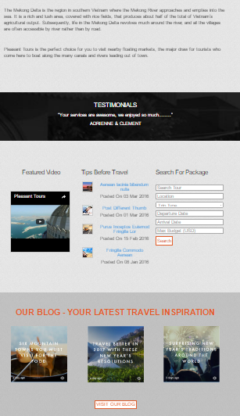

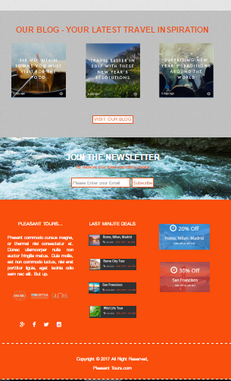

# STARTING OF “About Us PAGE”

<!doctype html>

<html>

<head>

<meta charset="utf-8">

<link rel="shortcut icon" href="img/favicon.ico">

<meta name="viewport" content="width=device-width, initial-scale=1, maximum-scale=1, , initial-scale=1.0">

<link rel="stylesheet" href="css/main_style.css">

<link rel="stylesheet" href="css/bootstrap.min.css">

<link rel="stylesheet" href="css/font-awesome.css">

<link rel="stylesheet" href="css/font-awesome.min.css">

<link rel="stylesheet" href="css/animate.css">

<link href="css/jquery-accordion-menu.css" rel="stylesheet" type="text/css" />

<link rel="stylesheet" type="text/css" href="engine1/style.css" />

<script type="text/javascript" src="engine1/jquery.js"></script>

<title>Pleasant Tours</title>

</head>

<body>

<div id="totop"></div>

<div class="login-btn text-right">

<div class="container">

<input type="search" placeholder="Search Tours.." class="tour-btn">

<a href="tour.html">

<span class="glyphicon glyphicon-search tour-btn search"></span>

</a>

<a href="admin.html" class="tour-btn">Login</a>

</div>

</div>

<header class="zind">

<div class="container">

<div class="col-xs-4 col-md-3">

<a href="">

<img src="img/logo.png" alt="">

</a>

</div>

<div class="col-xs-8 col-md-9">

<div id="fdw">

<!--nav-->

<nav>

<ul>

<li class="current">

<a href="index.html">home</a>

</li>

<li><a href="about.html">about us</a></li>

<li>

<a href="tour.html">Tours +<span class="arrow"></span></a>

<ul style="display: none;" class="sub_menu">

<li class="arrow_top"></li>

<li><a href="beach.html">BEACH TOUR</a></li>

<li><a href="hill.html">Hill Stations</a></li>

<li><a href="fort.html">Forts/Palaces</a></li>

<li><a href="south.html">SOUTH AMERICA</a></li>

<li><a href="australia.html">AUSTRALIA</a></li>

<li><a href="africa.html">AFRICA</a></li>

<li><a href="europe.html">EUROPE</a></li>

<li><a href="asia.html">ASIA</a></li>

</ul>

</li>

<li>

<a href="gallery.html">gallery</a>

</li>

<li><a href="contact.html">contact us</a></li>

</ul>

</nav>

</div>

</div>

</div>

</header>

<main><br>

<br>

<section class="">

<div class="container">

<h2 class="text-center h2-heading wow rotateInDownLeft">WHY PLEASANT TOURS</h2><br>

<br>

<div class="row">

<div class="col-md-6 wow flash">

<div class="col-sm-6">

<h3>OUR GUESTS LOVE US</h3><br><br>

<p>In the last year our guests have given us a 97% satisfaction rating, with over 13,900 independent reviews since partnering with feefo.</p><p id="readm1"></p>

<br><br>

<button class="readmore" onClick="readmore1()" class="text-center readmore">READ MORE--</button>

</div>

<div class="col-sm-6">

<img src="img/a.gif" alt="image">

</div>

</div>

<div class="col-md-6 wow flash">

<div class="col-sm-6">

<h3>BEST ESCORTED TOUR OPERATOR</h3><br>

<p>We're proud to have been awarded the Best Escorted Tour Operator at the 2015-16 Telegraph Travel Awards – voted by 75,000+ readers.</p><p id="readm2"></p>

<br><br>

<button class="readmore" onClick="readmore2()" class="text-center readmore">READ MORE--</button>

</div>

<div class="col-sm-6">

<img src="img/21.jpg" alt="image">

</div>

</div>

</div><br>

<br>

<div class="row">

<div class="col-md-6 wow flash">

<div class="col-sm-6">

<h3>DEEPER, RICHER, EXPERIENCES</h3>

<p>'Insider' isn't just a label to us. It's who we are. We not only unearth unique, authentic experiences, but our Travel Directors are hand-picked and trained to provide a truly personalised service.</p><p id="readm"></p>

<br><br>

<button class="readmore" onClick="readmore()" class="text-center readmore">READ MORE--</button>

</div>

<div class="col-sm-6">

<img src="img/22.jpg" alt="image">

</div>

</div>

<div class="col-md-6 wow flash">

<div class="col-sm-6">

<h3>EXPERTISE AND KNOWLEDGE</h3><br>

<p>With our 70 years of experience, we put you at the heart of everything we do, offering unparalleled expertise and inimitable local knowledge.</p><p id="readm3"></p>

<br><br>

<button class="readmore" onClick="readmore3()" class="text-center readmore">READ MORE--</button>

</div>

<div class="col-sm-6">

<img src="img/B.gif" alt="image">

</div>

</div>

</div>

</div>

</section>

<section>

<div class="container"><br>

<br>

<h2 class="h2-heading wow rubberBand">WARMEST GREETINGS FROM Pleasant Tours</h2><br>

<p class="wow fadeInRight">Pleasant Tours is a well-established organization serving for English & French speaking tourists with a renowned name in Vietnam’s tourism sector. It is professionally managed by an over years of experienced team and supported by well-educated, enthusiastic staffs, under the motto: “Create a new epoch in tourism".</p><br>

<p class="wow fadeInLeft">Every year, we welcome a large number of tourists coming from many countries in the world such as: France, Germany, Canada, England, China, Thailand, and many other countries. If you are looking for the best and trustworthy service providers in Southern Vietnam, Pleasant Tours should be your definite choice. </p><br>

<p class="wow fadeInRight">Every year, we welcome a large number of tourists coming from many countries in the world such as: France, Germany, Canada, England, China, Thailand, and many other countries. If you are looking for the best and trustworthy service providers in Southern Vietnam, Pleasant Tours should be your definite choice. </p><br>

<p class="wow fadeInLeft">We make a commitment to offer high-quality assistance at reasonable prices for tour packages. Please do not hesitate to get in touch with us for more information and useful advices about tour packages or anything about traveling to Southern Vietnam. Meanwhile, we would like to express special thank to beloved customers who are reading this. We look forward to receiving your response; and we wish to meet you here in Vietnam! With our best wishes for the success and prosperity.</p><br>

</div>

</section>

<section><br>

<br>

<br>

<div class="container">

<div class="row">

<div class="col-sm-6 wow zoomIn">

<img class="imh" src="img/23.jpg" alt="image">

</div>

<div class="col-sm-6 wow zoomIn">

<img class="imh" src="img/24.jpg" alt="image">

</div>

</div><br>

<div class="row">

<div class="col-sm-6 wow zoomIn">

<img src="img/25.jpg" class="imh" alt="image">

</div>

<div class="col-sm-6 wow zoomIn">

<div class="row">

<div class="col-sm-12 wow zoomIn">

<img src="img/26.jpg" class="imh" alt="image">

</div>

</div><br>

<div class="row">

<div class="col-sm-12 wow zoomIn">

<img src="img/27.jpg" class="imh" alt="image">

</div>

</div>

</div>

</div>

</div>

</section><br>

<br>

<section class="footer-top"><br>

<br>

<div class="container">

<div class="col-md-4 text-center"><br>

<h3>PLEASANT TOURS...</h3><br>

<p class="text-justify">Present commodo cursus magna, or thermal nisl consectetur et. Donec ullamcorper nulla non auctor fringilla metus. Duis mollis, est non commodo luctus, nisi erat porttitor ligula, eget lacinia odio sem nec elit. But up.</p><br>

<br>

<img src="img/14.png" alt="image">

<br><br>

<br>

<br>

<a href="https://www.facebook.com/Mohammad-Humayun-1128144880554699/" target="_blank"><i class="fa fa-google-plus icon"></i></a>

<a href="https://www.facebook.com/Mohammad-Humayun-1128144880554699/" target="_blank"><i class="fa fa-facebook icon"></i></a>

<a href="https://www.facebook.com/Mohammad-Humayun-1128144880554699/" target="_blank">

<i class="fa fa-twitter icon"></i></a>

<a href="https://www.facebook.com/Mohammad-Humayun-1128144880554699/" target="_blank">

<i class="fa fa-instagram icon"></i></a>

</div>

<div class="col-md-4 text-center"><br>

<h3>LAST MINUTE DEALS</h3><br>

<a href=""><img src="img/15.jpg" alt="image"></a><br><br>

<br>

<a href=""><img src="img/16.jpg" alt="image"></a><br><br><br>

<a href=""><img src="img/17.jpg" alt="image"></a><br><br><br>

<a href=""><img src="img/18.jpg" alt="image"></a><br><br><br>

</div>

<div class="col-md-4 text-center"><br>

<br>

<a href=""><img src="img/19.jpg" alt="image"></a><br><br><br>

<a href=""><img src="img/20.jpg" alt="image"></a>

</div>

</div><br>

<br>

</section>

</main>

<footer class="footer-top text-center"><br>

<div class="container"><br>

<p>Copyright &copy; 2017 All Right Reserved, <h3><a href="http://humayun-portfolio.firebaseapp.com/" target="_blank">Pleasant Tours.com</a></h3></p>

<br>

</div>

</footer>

<script src="js/jquery-3.1.0.min.js"></script>

<script src="js/bootstrap.min.js"></script>

<script src="js/sscroll.js"></script>

<script src="js/Totop.js"></script>

<script src="js/wow.js"></script>

<script>

new WOW().init();

</script>

<script src="js/index.js"></script>

<script src="js/jquery-1.11.2.min.js" type="text/javascript"></script>

<script src="js/jquery-accordion-menu.js" type="text/javascript"></script>

<script type="text/javascript" src="engine1/wowslider.js"></script>

<script type="text/javascript" src="engine1/script.js"></script>

</body>

</html>

***END OF “ABOUT US PAGE”***

# SCREEN SHOT OF “ABOUT US PAGE”

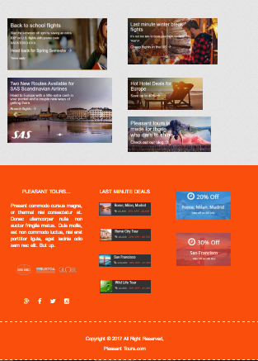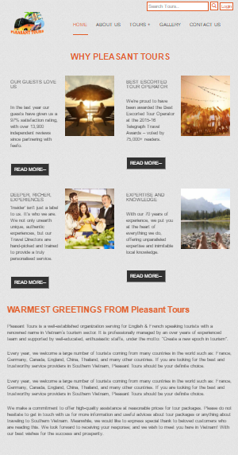

# STARTING OF “TOURS PAGE”

<!doctype html>

<html>

<head>

<meta charset="utf-8">

<link rel="shortcut icon" href="img/favicon.ico">

<meta name="viewport" content="width=device-width, initial-scale=1, maximum-scale=1, , initial-scale=1.0">

<link rel="stylesheet" href="css/main_style.css">

<link rel="stylesheet" href="css/bootstrap.min.css">

<link rel="stylesheet" href="css/font-awesome.css">

<link rel="stylesheet" href="css/font-awesome.min.css">

<link rel="stylesheet" href="css/animate.css">

<link href="css/jquery-accordion-menu.css" rel="stylesheet" type="text/css" />

<link rel="stylesheet" type="text/css" href="engine1/style.css" />

<script type="text/javascript" src="engine1/jquery.js"></script>

<title>Pleasant Tours</title>

</head>

<body>

<div id="totop"></div>

<div class="login-btn text-right">

<div class="container">

<input type="search" placeholder="Search Tours.." class="tour-btn">

<a href="tour.html">

<span class="glyphicon glyphicon-search tour-btn search"></span>

</a>

<a href="admin.html" class="tour-btn">Login</a>

</div>

</div>

<header class="zind">

<div class="container">

<div class="col-xs-4 col-md-3">

<a href="">

<img src="img/logo.png" alt="">

</a>

</div>

<div class="col-xs-8 col-md-9">

<div id="fdw">

<!--nav-->

<nav>

<ul>

<li class="current">

<a href="index.html">home</a>

</li>

<li><a href="about.html">about us</a></li>

<li>

<a href="tour.html">Tours +<span class="arrow"></span></a>

<ul style="display: none;" class="sub_menu">

<li class="arrow_top"></li>

<li><a href="beach.html">BEACH TOUR</a></li>

<li><a href="hill.html">Hill Stations</a></li>

<li><a href="fort.html">Forts/Palaces</a></li>

<li><a href="south.html">SOUTH AMERICA</a></li>

<li><a href="australia.html">AUSTRALIA</a></li>

<li><a href="africa.html">AFRICA</a></li>

<li><a href="europe.html">EUROPE</a></li>

<li><a href="asia.html">ASIA</a></li>

</ul>

</li>

<li>

<a href="gallery.html">gallery</a>

</li>

<li><a href="contact.html">contact us</a></li>

</ul>

</nav>

</div>

</div>

</div>

</header>

<main>

<section class="tour-slider">

<section>

<div class="container text-center"><br>

<br>

<br>

<br>

<br><br>

<br>

<div class="row">

<a href="download-file/list2.pdf" target="_blank" class="lod-c text-center wow zoomInUp">DOWNLOAD TOUR LIST-1</a>

</div><br>

<br>

<br>

<div class="row">

<a href="download-file/list.pdf" target="_blank" class="lod-c text-center wow zoomInUp">DOWNLOAD TOUR LIST-2</a>

</div><br>

<br>

<br>

<br>

<br>

</div>

</section>

</section>

<br>

<br>

<section class="">

<div class="container">

<h2 class="text-center h2-heading">WHERE CAN OUR TRIPS TAKE YOU?</h2><br>

<br>

<div class="row wow bounceInRight">

<a href="beach.html" class="tour">

<div class="col-md-6 a-tour">

<div class="col-sm-6">

<h3>Beach Tours</h3><br>

<p>Your perfect family getaway awaits you at Beaches all inclusive Resorts in Jamaica and Turks and Caicos. ...</p>

<br>

<a href="download-file/beach.docx" class="tour-btn">Download Information</a>

<br>

</div>

<div class="col-sm-6">

<img src="img/47.jpg" alt="image">

</div>

</div>

</a>

<a href="hill.html" class="tour">

<div class="col-md-6 a-tour">

<div class="col-sm-6">

<h3>Hill Stations</h3>

<p>This is a summer hill station...</p>

<br>

<a href="download-file/hill.docx" class="tour-btn">Download Information</a>

<br>

</div>

<div class="col-sm-6">

<img src="img/45.jpg" alt="image">

</div>

</div>

</a>

</div><br>

<br>

<div class="row wow bounceInLeft">

<a href="fort.html" class="tour">

<div class="col-md-6 a-tour">

<div class="col-sm-6">

<h3>Forts/Palaces</h3><br><br>

<p>Here are some of the Best Palaces and Forts you must visit and feel those Golden Times...</p>

<br>

<a href="download-file/fort.docx" class="tour-btn">Download Information</a>

<br>

</div>

<div class="col-sm-6">

<img src="img/46.jpg" alt="image">

</div>

</div>

</a>

<a href="south.html" class="tour">

<div class="col-md-6 a-tour">

<div class="col-sm-6">

<h3>SOUTH AMERICA</h3><br><br>

<p>Awaken your senses, exploring ancient civilisations, vibrant rainforests and...</p>

<br>

<a href="download-file/america.docx" class="tour-btn">Download Information</a>

<br>

</div>

<div class="col-sm-6">

<img src="img/c.gif" alt="image">

</div>

</div>

</a>

</div><br>

<br>

<div class="row wow bounceInRight">

<a href="australia.html" class="tour">

<div class="col-md-6 a-tour">

<div class="col-sm-6">

<h3>AUSTRALIA AND NEW ZEALAND</h3><br>

<p>Discover natural wonders in the...</p>

<br>

<a href="download-file/australia.docx" class="tour-btn">Download Information</a>

<br>

</div>

<div class="col-sm-6">

<img src="img/28.jpg" alt="image">

</div>

</div>

</a>

<a href="europe.html" class="tour">

<div class="col-md-6 a-tour">

<div class="col-sm-6">

<h3>EUROPE AND BRITAIN</h3>

<p>A true cultural Smorgasbord...</p>

<br>

<a href="download-file/europe.docx" class="tour-btn">Download Information</a>

<br>

</div>

<div class="col-sm-6">

<img src="img/29.jpg" alt="image">

</div>

</div>

</a>

</div><br>

<br>

<div class="row wow bounceInUp">

<a href="africa.html" class="tour">

<div class="col-md-6 a-tour">

<div class="col-sm-6">

<h3>AFRICA AND THE MIDDLE EAST</h3><br>

<p>Learn to haggle in...</p>

<br>

<a href="download-file/africa.docx" class="tour-btn">Download Information</a>

<br>

</div>

<div class="col-sm-6">

<img src="img/d.gif" alt="image">

</div>

</div>

</a>

<a href="asia.html" class="tour">

<div class="col-md-6 a-tour">

<div class="col-sm-6">

<h3>ASIA</h3><br>

<p>Be dazzled by shining pagodas, modern cityscapes, age-old heritage and new technology… explore...</p>

<br>

<a href="download-file/asia.docx" class="tour-btn">Download Information</a>

<br>

</div>

<div class="col-sm-6">

<img src="img/e.gif" alt="image">

</div>

</div>

</a>

</div>

</div>

</section><br>

<br>

<section>

<div class="container text-center"><br>

<br>

<h2 class="h2-heading">TOUR PRICE LIST</h2><br>

<br><br>

<br>

<div class="row">

<a href="download-file/list2.pdf" target="_blank" class="lod-c text-center wow zoomInUp">DOWNLOAD TOUR LIST-1</a>

</div><br>

<br>

<br>

<div class="row">

<a href="download-file/list.pdf" target="_blank" class="lod-c text-center wow zoomInUp">DOWNLOAD TOUR LIST-2</a>

</div><br>

<br>

<br>

<br>

<br>

</div>

</section>

<section>

<div class="container text-center">

<h3>CUSTOMER REVIEWS &amp; EXPERIENCES</h3>

<h2 class="h2-heading">#PLEASANT TOURS</h2><br>

<div class="row">

<div class="col-md-4 wow zoomInUp">

<img src="img/30.jpg" class="im" alt="image">

</div>

<div class="col-md-4 wow zoomInUp">

<img src="img/31.jpg" class="im" alt="image">

</div>

<div class="col-md-4 wow zoomInUp">

<img src="img/32.jpg" class="im" alt="image">

</div>

</div><br>

<br>

<div class="row">

<div class="col-md-4 wow zoomInUp">

<img src="img/33.jpg" class="im" alt="image">

</div>

<div class="col-md-4 wow zoomInUp">

<img src="img/34.jpg" class="im" alt="image">

</div>

<div class="col-md-4 wow zoomInUp">

<img src="img/35.jpg" class="im" alt="image">

</div>

</div><br>

<br>

<br>

<a class="lod-c text-center wow zoomInUp" onClick="cont()">LOAD MORE CONTENT</a>

<br>

<br>

<br><br>

<br>

<br>

<p id="cont"></p>

</div>

</section><br><br>

<br>

<br>

<section class="footer-top"><br>

<br>

<div class="container">

<div class="col-md-4 text-center"><br>

<h3>PLEASANT TOURS...</h3><br>

<p class="text-justify">Present commodo cursus magna, or thermal nisl consectetur et. Donec ullamcorper nulla non auctor fringilla metus. Duis mollis, est non commodo luctus, nisi erat porttitor ligula, eget lacinia odio sem nec elit. But up.</p><br>

<br>

<img src="img/14.png" alt="image">

<br><br>

<br>

<br>

<a href="https://www.facebook.com/Mohammad-Humayun-1128144880554699/" target="_blank"><i class="fa fa-google-plus icon"></i></a>

<a href="https://www.facebook.com/Mohammad-Humayun-1128144880554699/" target="_blank"><i class="fa fa-facebook icon"></i></a>

<a href="https://www.facebook.com/Mohammad-Humayun-1128144880554699/" target="_blank">

<i class="fa fa-twitter icon"></i></a>

<a href="https://www.facebook.com/Mohammad-Humayun-1128144880554699/" target="_blank">

<i class="fa fa-instagram icon"></i></a>

</div>

<div class="col-md-4 text-center"><br>

<h3>LAST MINUTE DEALS</h3><br>

<a href=""><img src="img/15.jpg" alt="image"></a><br><br>

<br>

<a href=""><img src="img/16.jpg" alt="image"></a><br><br><br>

<a href=""><img src="img/17.jpg" alt="image"></a><br><br><br>

<a href=""><img src="img/18.jpg"></a><br><br><br>

</div>

<div class="col-md-4 text-center"><br>

<br>

<a href=""><img src="img/19.jpg" alt="image"></a><br><br><br>

<a href=""><img src="img/20.jpg" alt="image"></a>

</div>

</div><br>

<br>

</section>

</main>

<footer class="footer-top text-center"><br>

<div class="container"><br>

<p>Copyright &copy; 2017 All Right Reserved, <h3><a href="http://humayun-portfolio.firebaseapp.com/" target="_blank">Pleasant Tours.com</a></h3></p>

<br>

</div>

</footer>

<script src="js/jquery-3.1.0.min.js"></script>

<script src="js/bootstrap.min.js"></script>

<script src="js/sscroll.js"></script>

<script src="js/Totop.js"></script>

<script src="js/wow.js"></script>

<script>

new WOW().init();

</script>

<script src="js/index.js"></script>

<script src="js/jquery-1.11.2.min.js" type="text/javascript"></script>

<script src="js/jquery-accordion-menu.js" type="text/javascript"></script>

<script type="text/javascript" src="engine1/wowslider.js"></script>

<script type="text/javascript" src="engine1/script.js"></script>

</body>

</html>

***END OF “TOURS PAGE”***

# SCREEN SHOT OF “TOURS PAGE”

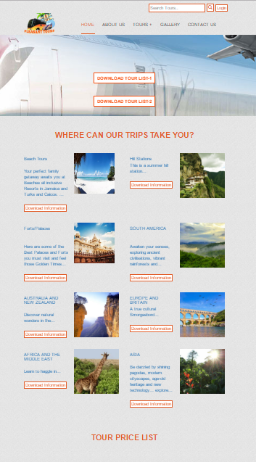

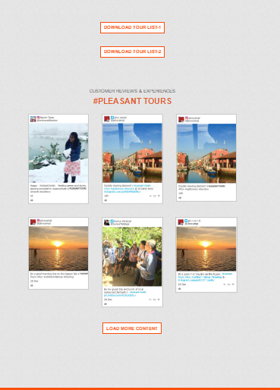

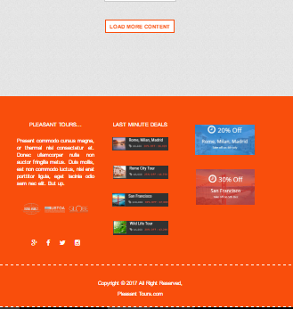

# STARTING OF “BEACH TOUR PAGE”

<!doctype html>

<html>

<head>

<meta charset="utf-8">

<link rel="shortcut icon" href="img/favicon.ico">

<meta name="viewport" content="width=device-width, initial-scale=1, maximum-scale=1, , initial-scale=1.0">

<link rel="stylesheet" href="css/main_style.css">

<link rel="stylesheet" href="css/bootstrap.min.css">

<link rel="stylesheet" href="css/font-awesome.css">

<link rel="stylesheet" href="css/font-awesome.min.css">

<link rel="stylesheet" href="css/animate.css">

<link href="css/jquery-accordion-menu.css" rel="stylesheet" type="text/css" />

<link rel="stylesheet" type="text/css" href="engine1/style.css" />

<script type="text/javascript" src="engine1/jquery.js"></script>

<title>Pleasant Tours</title>

</head>

<body>

<div id="totop"></div>

<div class="login-btn text-right">

<div class="container">

<input type="search" placeholder="Search Tours.." class="tour-btn">

<a href="tour.html">

<span class="glyphicon glyphicon-search tour-btn search"></span>

</a>

<a href="admin.html" class="tour-btn">Login</a>

</div>

</div>

<header class="zind">

<div class="container">

<div class="col-xs-4 col-md-3">

<a href="">

<img src="img/logo.png" alt="">

</a>

</div>

<div class="col-xs-8 col-md-9">

<div id="fdw">

<!--nav-->

<nav>

<ul>

<li class="current">

<a href="index.html">home</a>

</li>

<li><a href="about.html">about us</a></li>

<li>

<a href="tour.html">Tours +<span class="arrow"></span></a>

<ul style="display: none;" class="sub_menu">

<li class="arrow_top"></li>

<li><a href="beach.html">BEACH TOUR</a></li>

<li><a href="hill.html">Hill Stations</a></li>

<li><a href="fort.html">Forts/Palaces</a></li>

<li><a href="south.html">SOUTH AMERICA</a></li>

<li><a href="australia.html">AUSTRALIA</a></li>

<li><a href="africa.html">AFRICA</a></li>

<li><a href="europe.html">EUROPE</a></li>

<li><a href="asia.html">ASIA</a></li>

</ul>

</li>

<li>

<a href="gallery.html">gallery</a>

</li>

<li><a href="contact.html">contact us</a></li>

</ul>

</nav>

</div>

</div>

</div>

</header>

<main>

<section class="beach-slider">

<div class="container text-center">

<div class="tour-cen wow jello">

<h2>Beach Tours</h2>

<p>Select Country.</p>

<p class="js-module-view-all-trips">

<span class="tour-sel-h">Explore by country:</span>&nbsp;

<select class="tour-sel">

<option value="">America</option>

<option value="">Dubai</option>

<option value="">Pakistan</option>

<option value="">London</option>

<option value="">India</option>

</select>

<a href="tour.html">

<button type="submit" class="tour-btn">

Go >

</button>

</a>

</p>

</div>

</div>

</section>

<br>

<br>

<section>

<div class="container">

<h2 class="h2-heading text-center">All Beach Tour Places</h3><br>

<br>

<h3> A Day Doc Let Beach Excursion - Nha Trang</h3><br>

<img src="img/48.jpg" alt="image"><br><br>

<h4>PROGRAM DETAILS</h4>

<p class="text-justify">

Start today’s journey with a hotel pick-up at 8:30 AM and enjoy a beautiful one hour drive through small mountains and idyllic seaside scenery before arriving to Doc Let. En route, stop at Ninh Thuy to visit a small and charming fishing village. Visiting this traditional village is a good way to discover local daily life and work activities. After, head to the beach to relax, spending time sunbathing and swimming. Upon return to Nha Trang, visit picturesque Ninh Diem salt fields. Salt water is directed into fields and left for days to evaporate. The white mineral is then removed and left to dry before harvesting. Continue back to Nha Trang after a relaxing day on the north coast of Nha Trang.

(Lunch is not included; guests may want to choose to have hotel prepare a box lunch for beach picnic or have lunch at the White Sand Doclet Resort and Spa).

Recommendations: the best time to attend this tour is from January to September in order to avoid the raining season.</p>

<h3>PRICING: Please <a href="contact.html">contact us</a> for rates</h3>

<p>Our services include:<br><br>

• English speaking local guide (for other languages supplements apply)<br>

• Tours and transfers as mentioned by private air conditioned vehicle<br>

<br>

Our services do not include:<br>

<br>

• Other meals than mentioned<br>

• Other services than mentioned

</p><br>

<h3>Download other tours Information</h3><br>

<a href="download-file/beach.docx" class="tour-btn">Download Information</a><br>

</div>

</section><br>

<br>

<br>

<section class="p1">

<div class="container text-center"><br>

<br>

<h2 class="join-heading">JOIN THE NEWSLETTER</h2>

<p style="color:#f94e0c;">To receive our best monthly deals </p><br>

<input class="tour-btn" required type="text" placeholder="Please Enter your Email">

<span>

<button class="tour-btn" onClick="subscribe()">Subscribe</button>

</span>

</div>

<br><br>

</section>

<section class="footer-top"><br>

<br>

<div class="container">

<div class="col-md-4 text-center"><br>

<h3>Pleasant TOURS...</h3><br>

<p class="text-justify">Present commodo cursus magna, or thermal nisl consectetur et. Donec ullamcorper nulla non auctor fringilla metus. Duis mollis, est non commodo luctus, nisi erat porttitor ligula, eget lacinia odio sem nec elit. But up.</p><br>

<br>

<img src="img/14.png" alt="image">

<br><br>

<br>

<br>

<a href="https://www.facebook.com/Mohammad-Humayun-1128144880554699/" target="_blank"><i class="fa fa-google-plus icon"></i></a>

<a href="https://www.facebook.com/Mohammad-Humayun-1128144880554699/" target="_blank"><i class="fa fa-facebook icon"></i></a>

<a href="https://www.facebook.com/Mohammad-Humayun-1128144880554699/" target="_blank">

<i class="fa fa-twitter icon"></i></a>

<a href="https://www.facebook.com/Mohammad-Humayun-1128144880554699/" target="_blank">

<i class="fa fa-instagram icon"></i></a>

</div>

<div class="col-md-4 text-center"><br>

<h3>LAST MINUTE DEALS</h3><br>

<a href=""><img src="img/15.jpg" alt="image"></a><br><br>

<br>

<a href=""><img src="img/16.jpg" alt="image"></a><br><br><br>

<a href=""><img src="img/17.jpg" alt="image"></a><br><br><br>

<a href=""><img src="img/18.jpg"></a><br><br><br>

</div>

<div class="col-md-4 text-center"><br>

<br>

<a href=""><img src="img/19.jpg" alt="image"></a><br><br><br>

<a href=""><img src="img/20.jpg" alt="image"></a>

</div>

</div><br>

<br>

</section>

</main>

<footer class="footer-top text-center"><br>

<div class="container"><br>

<p>Copyright &copy; 2017 All Right Reserved, <h3><a href="http://humayun-portfolio.firebaseapp.com/" target="_blank">Pleasant Tours.com</a></h3></p>

<br>

</div>

</footer>

<script src="js/jquery-3.1.0.min.js"></script>

<script src="js/bootstrap.min.js"></script>

<script src="js/sscroll.js"></script>

<script src="js/Totop.js"></script>

<script src="js/wow.js"></script>

<script>

new WOW().init();

</script>

<script src="js/index.js"></script>

<script src="js/jquery-1.11.2.min.js" type="text/javascript"></script>

<script src="js/jquery-accordion-menu.js" type="text/javascript"></script>

<script type="text/javascript" src="engine1/wowslider.js"></script>

<script type="text/javascript" src="engine1/script.js"></script>

</body>

</html>

***END OF “BEACH TOUR PAGE”***

# SCREEN SHOT OF “BEACH TOUR PAGE”

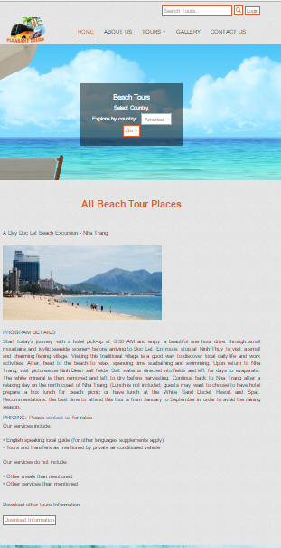

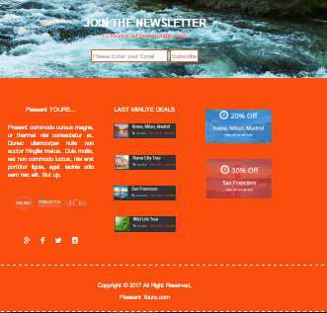

# STARTING OF “Hill Stations PAGE”

<!doctype html>

<html>

<head>

<meta charset="utf-8">

<link rel="shortcut icon" href="img/favicon.ico">

<meta name="viewport" content="width=device-width, initial-scale=1, maximum-scale=1, , initial-scale=1.0">

<link rel="stylesheet" href="css/main_style.css">

<link rel="stylesheet" href="css/bootstrap.min.css">

<link rel="stylesheet" href="css/font-awesome.css">

<link rel="stylesheet" href="css/font-awesome.min.css">

<link rel="stylesheet" href="css/animate.css">

<link href="css/jquery-accordion-menu.css" rel="stylesheet" type="text/css" />

<link rel="stylesheet" type="text/css" href="engine1/style.css" />

<script type="text/javascript" src="engine1/jquery.js"></script>

<title>Pleasant Tours</title>

</head>

<body>

<div id="totop"></div>

<div class="login-btn text-right">

<div class="container">

<input type="search" placeholder="Search Tours.." class="tour-btn">

<a href="tour.html">

<span class="glyphicon glyphicon-search tour-btn search"></span>

</a>

<a href="admin.html" class="tour-btn">Login</a>

</div>

</div>

<header class="zind">

<div class="container">

<div class="col-xs-4 col-md-3">

<a href="">

<img src="img/logo.png" alt="">

</a>

</div>

<div class="col-xs-8 col-md-9">

<div id="fdw">

<!--nav-->

<nav>

<ul>

<li class="current">

<a href="index.html">home</a>

</li>

<li><a href="about.html">about us</a></li>

<li>

<a href="tour.html">Tours +<span class="arrow"></span></a>

<ul style="display: none;" class="sub_menu">

<li class="arrow_top"></li>

<li><a href="beach.html">BEACH TOUR</a></li>

<li><a href="hill.html">Hill Stations</a></li>

<li><a href="fort.html">Forts/Palaces</a></li>

<li><a href="south.html">SOUTH AMERICA</a></li>

<li><a href="australia.html">AUSTRALIA</a></li>

<li><a href="africa.html">AFRICA</a></li>

<li><a href="europe.html">EUROPE</a></li>

<li><a href="asia.html">ASIA</a></li>

</ul>

</li>

<li>

<a href="gallery.html">gallery</a>

</li>

<li><a href="contact.html">contact us</a></li>

</ul>

</nav>

</div>

</div>

</div>

</header>

<main>

<section class="hill-slider">

<div class="container text-center">

<div class="tour-cen wow jello">

<h2>Hill Station Tours</h2>

<p>Select Country.</p>

<p class="js-module-view-all-trips">

<span class="tour-sel-h">Explore by country:</span>&nbsp;

<select class="tour-sel">

<option value="">America</option>

<option value="">Dubai</option>

<option value="">Pakistan</option>

<option value="">London</option>

<option value="">India</option>

</select>

<button type="submit" class="tour-btn">

Go >

</button>

</p>

</div>

</div>

</section>

<br>

<br>

<section>

<div class="container">

<h2 class="h2-heading text-center">All Hill Staions Places</h3><br>

<br>

<h3> Tusheti, Georgia</h3><br>

<img src="img/hill.png" alt="image"><br><br>

<h4>DETAILS</h4>

<p class="text-justify">

A 3 hour drive along one of the worlds most dangerous roads (or so says the BBC) you enter the center of the Caucasus, where Georgia borders Dagastan and Chechnya. For a region with such a bad image, the scenery is shockingly beautiful! Old slate villages are dotted on the mountains, with large towers among them to defend their border. Nowadays it's slowly turning into tourism towns, but you can still feel the old shepherd atmosphere and with a little luck you can see bears. This is a must go, stay at a locals place, enjoy their hospitality from wine, cheeses and Georgian bread... This is Sovjets Italy!

.</p>

<h3>PRICING: Please <a href="contact.html">contact us</a> for rates</h3>

<p>Our services include:<br><br>

• English speaking local guide (for other languages supplements apply)<br>

• Tours and transfers as mentioned by private air conditioned vehicle<br>

<br>

Our services do not include:<br>

<br>

• Other meals than mentioned<br>

• Other services than mentioned

</p><br>

<h3>Download other Hill Stations Information</h3><br>

<a href="download-file/hill.docx" class="tour-btn">Download Information</a><br>

</div>

</section><br>

<br>

<br>

<section class="p1">

<div class="container text-center"><br>

<br>

<h2 class="join-heading">JOIN THE NEWSLETTER</h2>

<p style="color:#f94e0c;">To receive our best monthly deals </p><br>

<input class="tour-btn" required type="text" placeholder="Please Enter your Email">

<span>

<button class="tour-btn" onClick="subscribe()">Subscribe</button>

</span>

</div>

<br><br>

</section>

<section class="footer-top"><br>

<br>

<div class="container">

<div class="col-md-4 text-center"><br>

<h3>Pleasant TOURS...</h3><br>

<p class="text-justify">Present commodo cursus magna, or thermal nisl consectetur et. Donec ullamcorper nulla non auctor fringilla metus. Duis mollis, est non commodo luctus, nisi erat porttitor ligula, eget lacinia odio sem nec elit. But up.</p><br>

<br>

<img src="img/14.png" alt="image">

<br><br>

<br>

<br>

<a href="https://www.facebook.com/Mohammad-Humayun-1128144880554699/" target="_blank"><i class="fa fa-google-plus icon"></i></a>

<a href="https://www.facebook.com/Mohammad-Humayun-1128144880554699/" target="_blank"><i class="fa fa-facebook icon"></i></a>

<a href="https://www.facebook.com/Mohammad-Humayun-1128144880554699/" target="_blank">

<i class="fa fa-twitter icon"></i></a>

<a href="https://www.facebook.com/Mohammad-Humayun-1128144880554699/" target="_blank">

<i class="fa fa-instagram icon"></i></a>

</div>

<div class="col-md-4 text-center"><br>

<h3>LAST MINUTE DEALS</h3><br>

<a href=""><img src="img/15.jpg" alt="image"></a><br><br>

<br>

<a href=""><img src="img/16.jpg" alt="image"></a><br><br><br>

<a href=""><img src="img/17.jpg" alt="image"></a><br><br><br>

<a href=""><img src="img/18.jpg"></a><br><br><br>

</div>

<div class="col-md-4 text-center"><br>

<br>

<a href=""><img src="img/19.jpg" alt="image"></a><br><br><br>

<a href=""><img src="img/20.jpg" alt="image"></a>

</div>

</div><br>

<br>

</section>

</main>

<footer class="footer-top text-center"><br>

<div class="container"><br>

<p>Copyright &copy; 2017 All Right Reserved, <h3><a href="http://humayun-portfolio.firebaseapp.com/" target="_blank">Pleasant Tours.com</a></h3></p>

<br>

</div>

</footer>

<script src="js/jquery-3.1.0.min.js"></script>

<script src="js/bootstrap.min.js"></script>

<script src="js/sscroll.js"></script>

<script src="js/Totop.js"></script>

<script src="js/wow.js"></script>

<script>

new WOW().init();

</script>

<script src="js/index.js"></script>

<script src="js/jquery-1.11.2.min.js" type="text/javascript"></script>

<script src="js/jquery-accordion-menu.js" type="text/javascript"></script>

<script type="text/javascript" src="engine1/wowslider.js"></script>

<script type="text/javascript" src="engine1/script.js"></script>

</body>

</html>

***END OF “Hill Stations PAGE”***

# SCREEN SHOT OF “Hill Stations PAGE”

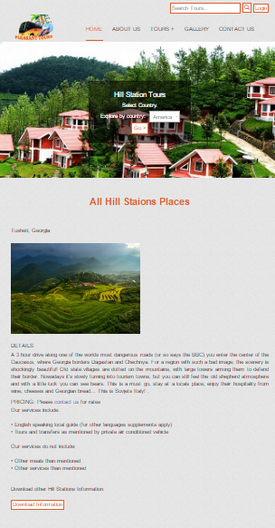

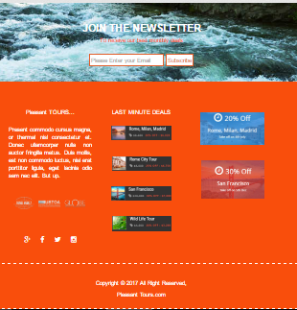

# STARTING OF “Fort/Palaces PAGE”

<!doctype html>

<html>

<head>

<meta charset="utf-8">

<link rel="shortcut icon" href="img/favicon.ico">

<meta name="viewport" content="width=device-width, initial-scale=1, maximum-scale=1, , initial-scale=1.0">

<link rel="stylesheet" href="css/main_style.css">

<link rel="stylesheet" href="css/bootstrap.min.css">

<link rel="stylesheet" href="css/font-awesome.css">

<link rel="stylesheet" href="css/font-awesome.min.css">

<link rel="stylesheet" href="css/animate.css">

<link href="css/jquery-accordion-menu.css" rel="stylesheet" type="text/css" />

<link rel="stylesheet" type="text/css" href="engine1/style.css" />

<script type="text/javascript" src="engine1/jquery.js"></script>

<title>Pleasant Tours</title>

</head>

<body>

<div id="totop"></div>

<div class="login-btn text-right">

<div class="container">

<input type="search" placeholder="Search Tours.." class="tour-btn">

<a href="tour.html">

<span class="glyphicon glyphicon-search tour-btn search"></span>

</a>

<a href="admin.html" class="tour-btn">Login</a>

</div>

</div>

<header class="zind">

<div class="container">

<div class="col-xs-4 col-md-3">

<a href="">

<img src="img/logo.png" alt="">

</a>

</div>

<div class="col-xs-8 col-md-9">

<div id="fdw">

<!--nav-->

<nav>

<ul>

<li class="current">

<a href="index.html">home</a>

</li>

<li><a href="about.html">about us</a></li>

<li>

<a href="tour.html">Tours +<span class="arrow"></span></a>

<ul style="display: none;" class="sub_menu">

<li class="arrow_top"></li>

<li><a href="beach.html">BEACH TOUR</a></li>

<li><a href="hill.html">Hill Stations</a></li>

<li><a href="fort.html">Forts/Palaces</a></li>

<li><a href="south.html">SOUTH AMERICA</a></li>

<li><a href="australia.html">AUSTRALIA</a></li>

<li><a href="africa.html">AFRICA</a></li>

<li><a href="europe.html">EUROPE</a></li>

<li><a href="asia.html">ASIA</a></li>

</ul>

</li>

<li>

<a href="gallery.html">gallery</a>

</li>

<li><a href="contact.html">contact us</a></li>

</ul>

</nav>

</div>

</div>

</div>

</header>

<main>

<section class="fort-slider">

<div class="container text-center">

<div class="tour-cen wow jello">

<h2>Fort/Palaces Tours</h2>

<p>Select Country.</p>

<p class="js-module-view-all-trips">

<span class="tour-sel-h">Explore by country:</span>&nbsp;

<select class="tour-sel">

<option value="">India</option>

<option value="">Dubai</option>

<option value="">Pakistan</option>

<option value="">London</option>

<option value="">Turkey</option>

</select>

<a href="tour.html">

<button type="submit" class="tour-btn">

Go >

</button>

</a>

</p>

</div>

</div>

</section>

<br>

<br>

<section>

<div class="container">

<h2 class="h2-heading text-center">All Fort/Palaces Tour Places</h3><br>

<br>

<h3> Taaj Mahal</h3><br>

<img src="img/54.jpg" alt="image"><br><br>

<h4>DETAILS</h4>

<p class="text-justify">

The Taj Mahal (/ˌtɑːdʒ məˈhɑːl/, more often /ˈtɑːʒ/;[3] meaning Crown of the Palace[4]) is an ivory-white marble mausoleum on the south bank of the Yamuna river in the Indian city of Agra. It was commissioned in 1632 by the Mughal emperor, Shah Jahan (reigned 1628–1658), to house the tomb of his favourite wife, Mumtaz Mahal. The tomb is the centrepiece of a 17-hectare (42-acre)[5] complex, which includes a mosque and a guest house, and is set in formal gardens bounded on three sides by a crenellated wall.</p>

<p class="text-justify">

Construction of the mausoleum was essentially completed in 1643 but work continued on other phases of the project for another 10 years. The Taj Mahal complex is believed to have been completed in its entirety in 1653 at a cost estimated at the time to be around 32 million rupees, which in 2015 would be approximately 52.8 billion rupees (US$827 million). The construction project employed some 20,000 artisans under the guidance of a board of architects led by the court architect to the emperor, Ustad Ahmad Lahauri.</p>

<p class="text-justify">

The Taj Mahal was designated as a UNESCO World Heritage Site in 1983 for being "the jewel of Muslim art in India and one of the universally admired masterpieces of the world's heritage". Described by Nobel laureate Rabindranath Tagore as "the tear-drop on the cheek of time", it is regarded by many as the best example of Mughal architecture and a symbol of India's rich history. The Taj Mahal attracts 7–8 million visitors a year. In 2007, it was declared a winner of the New7Wonders of the World (2000–2007) initiative.</p>

<h3>PRICING: Please <a href="contact.html">contact us</a> for rates</h3>

<p>Our services include:<br><br>

• English speaking local guide (for other languages supplements apply)<br>

• Tours and transfers as mentioned by private air conditioned vehicle<br>

<br>

Our services do not include:<br>

<br>

• Other meals than mentioned<br>

• Other services than mentioned

</p><br>

<h3>Download other tours Information</h3><br>

<a href="download-file/fort.docx" class="tour-btn">Download Information</a><br>

</div>

</section><br>

<br>

<br>

<section class="p1">

<div class="container text-center"><br>

<br>

<h2 class="join-heading">JOIN THE NEWSLETTER</h2>

<p style="color:#f94e0c;">To receive our best monthly deals </p><br>

<input class="tour-btn" required type="text" placeholder="Please Enter your Email">

<span>

<button class="tour-btn" onClick="subscribe()">Subscribe</button>

</span>

</div>

<br><br>

</section>

<section class="footer-top"><br>

<br>

<div class="container">

<div class="col-md-4 text-center"><br>

<h3>Pleasant TOURS...</h3><br>

<p class="text-justify">Present commodo cursus magna, or thermal nisl consectetur et. Donec ullamcorper nulla non auctor fringilla metus. Duis mollis, est non commodo luctus, nisi erat porttitor ligula, eget lacinia odio sem nec elit. But up.</p><br>

<br>

<img src="img/14.png" alt="image">

<br><br>

<br>

<br>

<a href="https://www.facebook.com/Mohammad-Humayun-1128144880554699/" target="_blank"><i class="fa fa-google-plus icon"></i></a>

<a href="https://www.facebook.com/Mohammad-Humayun-1128144880554699/" target="_blank"><i class="fa fa-facebook icon"></i></a>

<a href="https://www.facebook.com/Mohammad-Humayun-1128144880554699/" target="_blank">

<i class="fa fa-twitter icon"></i></a>

<a href="https://www.facebook.com/Mohammad-Humayun-1128144880554699/" target="_blank">

<i class="fa fa-instagram icon"></i></a>

</div>

<div class="col-md-4 text-center"><br>

<h3>LAST MINUTE DEALS</h3><br>

<a href=""><img src="img/15.jpg" alt="image"></a><br><br>

<br>

<a href=""><img src="img/16.jpg" alt="image"></a><br><br><br>

<a href=""><img src="img/17.jpg" alt="image"></a><br><br><br>

<a href=""><img src="img/18.jpg"></a><br><br><br>

</div>

<div class="col-md-4 text-center"><br>

<br>

<a href=""><img src="img/19.jpg" alt="image"></a><br><br><br>

<a href=""><img src="img/20.jpg" alt="image"></a>

</div>

</div><br>

<br>

</section>

</main>

<footer class="footer-top text-center"><br>

<div class="container"><br>

<p>Copyright &copy; 2017 All Right Reserved, <h3><a href="http://humayun-portfolio.firebaseapp.com/" target="_blank">Pleasant Tours.com</a></h3></p>

<br>

</div>

</footer>

<script src="js/jquery-3.1.0.min.js"></script>

<script src="js/bootstrap.min.js"></script>

<script src="js/sscroll.js"></script>

<script src="js/Totop.js"></script>

<script src="js/wow.js"></script>

<script>

new WOW().init();

</script>

<script src="js/index.js"></script>

<script src="js/jquery-1.11.2.min.js" type="text/javascript"></script>

<script src="js/jquery-accordion-menu.js" type="text/javascript"></script>

<script type="text/javascript" src="engine1/wowslider.js"></script>

<script type="text/javascript" src="engine1/script.js"></script>

</body>

</html>

***END OF “Fort/Palaces PAGE”***

# SCREEN SHOT OF “Fort/Palaces PAGE”

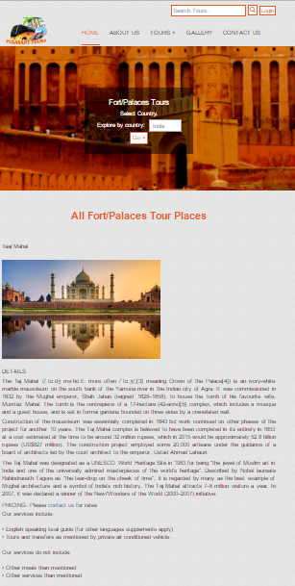

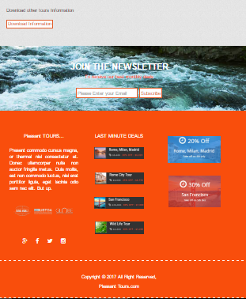

# STARTING OF “South America PAGE”

<!doctype html>

<html>

<head>

<meta charset="utf-8">

<link rel="shortcut icon" href="img/favicon.ico">

<meta name="viewport" content="width=device-width, initial-scale=1, maximum-scale=1, , initial-scale=1.0">

<link rel="stylesheet" href="css/main_style.css">

<link rel="stylesheet" href="css/bootstrap.min.css">

<link rel="stylesheet" href="css/font-awesome.css">

<link rel="stylesheet" href="css/font-awesome.min.css">

<link rel="stylesheet" href="css/animate.css">

<link href="css/jquery-accordion-menu.css" rel="stylesheet" type="text/css" />

<link rel="stylesheet" type="text/css" href="engine1/style.css" />

<script type="text/javascript" src="engine1/jquery.js"></script>

<title>Pleasant Tours</title>

</head>

<body>

<div id="totop"></div>

<div class="login-btn text-right">

<div class="container">

<input type="search" placeholder="Search Tours.." class="tour-btn">

<a href="tour.html">

<span class="glyphicon glyphicon-search tour-btn search"></span>

</a>

<a href="admin.html" class="tour-btn">Login</a>

</div>

</div>

<header class="zind">

<div class="container">

<div class="col-xs-4 col-md-3">

<a href="">

<img src="img/logo.png" alt="">

</a>

</div>

<div class="col-xs-8 col-md-9">

<div id="fdw">

<!--nav-->

<nav>

<ul>

<li class="current">

<a href="index.html">home</a>

</li>

<li><a href="about.html">about us</a></li>

<li>

<a href="tour.html">Tours +<span class="arrow"></span></a>

<ul style="display: none;" class="sub_menu">

<li class="arrow_top"></li>

<li><a href="beach.html">BEACH TOUR</a></li>

<li><a href="hill.html">Hill Stations</a></li>

<li><a href="fort.html">Forts/Palaces</a></li>

<li><a href="south.html">SOUTH AMERICA</a></li>

<li><a href="australia.html">AUSTRALIA</a></li>

<li><a href="africa.html">AFRICA</a></li>

<li><a href="europe.html">EUROPE</a></li>

<li><a href="asia.html">ASIA</a></li>

</ul>

</li>

<li>

<a href="gallery.html">gallery</a>

</li>

<li><a href="contact.html">contact us</a></li>

</ul>

</nav>

</div>

</div>

</div>

</header>

<main>

<section class="south-slider">

<div class="container">

<div class="tour-cen wow fadeIn">

<h2>South America</h2>

<p>Home to the world’s biggest rainforest, largest river and tallest waterfall, South America is a continent of dizzying natural splendor.</p>

<p class="js-module-view-all-trips">

<span class="tour-sel-h">Explore by country:</span>&nbsp;

<select class="tour-sel">

<option value="">Argentina</option>

<option value="">Brazil</option>

<option value="">Chile</option>

<option value="">Ecuador</option>

<option value="">Peru</option>

</select>

<a href="tour.html">

<button type="submit" class="tour-btn">

Go >

</button>

</a>

</p>

</div>

</div>

</section>

<br>

<br>

<section>

<div class="container wow fadeInUpBig">

<h3>Take a tour of South America with us</h3>

<h3>From spectacular Rio to secretive ruins</h3>

<p>The colliding cultures of its indigenous people and its Spanish colonisers have given South America a fascinatingly eclectic man-made landscape. One of its great cities is a stylish, sprawling modern metropolis, famous across the globe for its carnival and beaches. The other is a mystical complex of 15th century Incan ruins, which was hidden from the outside world for more than three centuries. </p>

<h3>PRICING: Please <a href="contact.html">contact us</a> for rates</h3>

<p>Our services include:<br><br>

• English speaking local guide (for other languages supplements apply)<br>

• Tours and transfers as mentioned by private air conditioned vehicle<br>

<br>

Our services do not include:<br>

<br>

• Other meals than mentioned<br>

• Other services than mentioned

</p><br>

<h3>Download other tours Information</h3><br>

<a href="download-file/america.docx" class="tour-btn">Download Information</a><br>

</div>

</section><br>

<br>

<br>

<section class="p1">

<div class="container text-center"><br>

<br>

<h2 class="join-heading">JOIN THE NEWSLETTER</h2>

<p style="color:#f94e0c;">To receive our best monthly deals </p><br>

<input class="tour-btn" required type="text" placeholder="Please Enter your Email">

<span>

<button class="tour-btn" onClick="subscribe()">Subscribe</button>

</span>

</div>

<br><br>

</section>

<section class="footer-top"><br>

<br>

<div class="container">

<div class="col-md-4 text-center"><br>

<h3>Pleasant TOURS...</h3><br>

<p class="text-justify">Present commodo cursus magna, or thermal nisl consectetur et. Donec ullamcorper nulla non auctor fringilla metus. Duis mollis, est non commodo luctus, nisi erat porttitor ligula, eget lacinia odio sem nec elit. But up.</p><br>

<br>

<img src="img/14.png">

<br><br>

<br>

<br>

<a href="https://www.facebook.com/Mohammad-Humayun-1128144880554699/" target="_blank"><i class="fa fa-google-plus icon"></i></a>

<a href="https://www.facebook.com/Mohammad-Humayun-1128144880554699/" target="_blank"><i class="fa fa-facebook icon"></i></a>

<a href="https://www.facebook.com/Mohammad-Humayun-1128144880554699/" target="_blank">

<i class="fa fa-twitter icon"></i></a>

<a href="https://www.facebook.com/Mohammad-Humayun-1128144880554699/" target="_blank">

<i class="fa fa-instagram icon"></i></a>

</div>

<div class="col-md-4 text-center"><br>

<h3>LAST MINUTE DEALS</h3><br>

<a href=""><img src="img/15.jpg"></a><br><br>

<br>

<a href=""><img src="img/16.jpg"></a><br><br><br>

<a href=""><img src="img/17.jpg"></a><br><br><br>

<a href=""><img src="img/18.jpg"></a><br><br><br>

</div>

<div class="col-md-4 text-center"><br>

<br>

<a href=""><img src="img/19.jpg"></a><br><br><br>

<a href=""><img src="img/20.jpg"></a>

</div>

</div><br>

<br>

</section>

</main>

<footer class="footer-top text-center"><br>

<div class="container"><br>

<p>Copyright &copy; 2017 All Right Reserved, <h3><a href="http://humayun-portfolio.firebaseapp.com/" target="_blank">Pleasant Tours.com</a></h3></p>

<br>

</div>

</footer>

<script src="js/jquery-3.1.0.min.js"></script>

<script src="js/bootstrap.min.js"></script>

<script src="js/sscroll.js"></script>

<script src="js/Totop.js"></script>

<script src="js/wow.js"></script>

<script>

new WOW().init();

</script>

<script src="js/index.js"></script>

<script src="js/jquery-1.11.2.min.js" type="text/javascript"></script>

<script src="js/jquery-accordion-menu.js" type="text/javascript"></script>

<script type="text/javascript" src="engine1/wowslider.js"></script>

<script type="text/javascript" src="engine1/script.js"></script>

</body>

</html>

***END OF “South America PAGE”***

# SCREEN SHOT OF “South America PAGE”

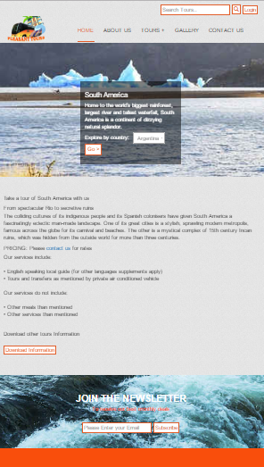

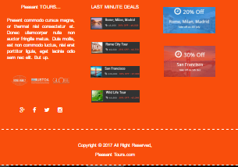

# STARTING OF “Australia PAGE”

<!doctype html>

<html>

<head>

<meta charset="utf-8">

<link rel="shortcut icon" href="img/favicon.ico">

<meta name="viewport" content="width=device-width, initial-scale=1, maximum-scale=1, , initial-scale=1.0">

<link rel="stylesheet" href="css/main_style.css">

<link rel="stylesheet" href="css/bootstrap.min.css">

<link rel="stylesheet" href="css/font-awesome.css">

<link rel="stylesheet" href="css/font-awesome.min.css">

<link rel="stylesheet" href="css/animate.css">

<link href="css/jquery-accordion-menu.css" rel="stylesheet" type="text/css" />

<link rel="stylesheet" type="text/css" href="engine1/style.css" />

<script type="text/javascript" src="engine1/jquery.js"></script>

<title>Pleasant Tours</title>

</head>

<body>

<div id="totop"></div>

<div class="login-btn text-right">

<div class="container">

<input type="search" placeholder="Search Tours.." class="tour-btn">

<a href="tour.html">

<span class="glyphicon glyphicon-search tour-btn search"></span>

</a>

<a href="admin.html" class="tour-btn">Login</a>

</div>

</div>

<header class="zind">

<div class="container">

<div class="col-xs-4 col-md-3">

<a href="">

<img src="img/logo.png" alt="">

</a>

</div>

<div class="col-xs-8 col-md-9">

<div id="fdw">

<!--nav-->

<nav>

<ul>

<li class="current">

<a href="index.html">home</a>

</li>

<li><a href="about.html">about us</a></li>

<li>

<a href="tour.html">Tours +<span class="arrow"></span></a>

<ul style="display: none;" class="sub_menu">

<li class="arrow_top"></li>

<li><a href="beach.html">BEACH TOUR</a></li>

<li><a href="hill.html">Hill Stations</a></li>

<li><a href="fort.html">Forts/Palaces</a></li>

<li><a href="south.html">SOUTH AMERICA</a></li>

<li><a href="australia.html">AUSTRALIA</a></li>

<li><a href="africa.html">AFRICA</a></li>

<li><a href="europe.html">EUROPE</a></li>

<li><a href="asia.html">ASIA</a></li>

</ul>

</li>

<li>

<a href="gallery.html">gallery</a>

</li>

<li><a href="contact.html">contact us</a></li>

</ul>

</nav>

</div>

</div>

</div>

</header>

<main>

<section class="aus-slider">

<div class="container">

<div class="tour-cen wow rubberBand">

<h2>Australia & South Pacific</h2>

<p>Connected by the Tasman Sea, you’d be forgiven for thinking that Australia and New Zealand are two sides of the same coin – but the differences are endless.</p>

<p class="js-module-view-all-trips">

<span class="tour-sel-h">Explore by country:</span>&nbsp;

<select class="tour-sel">

<option value="">Australia</option>

<option value="">New Zealand</option>

</select>

<a href="tour.html">

<button type="submit" class="tour-btn">

Go >

</button>

</a>

</p>

</div>

</div>

</section>

<br>

<br>

<section>

<div class="container wow bounceIn">

<h3>Take a tour of Australia and the South Pacific with us</h3>

<h3>Spectacular scenery and proud people</h3>

<p>Don a snorkel and swim among the sea life around the Great Barrier Reef, feed kangaroos in a nature reserve, witness the thunderous spray of blowholes in Paparoa. And sail around Milford Sound, one of the most spectacular fjords in the world. </p>

<h3>PRICING: Please <a href="contact.html">contact us</a> for rates</h3>

<p>Our services include:<br><br>

• English speaking local guide (for other languages supplements apply)<br>

• Tours and transfers as mentioned by private air conditioned vehicle<br>

<br>

Our services do not include:<br>

<br>

• Other meals than mentioned<br>

• Other services than mentioned

</p><br>

<h3>Download other tours Information</h3><br>

<a href="download-file/america.docx" class="tour-btn">Download Information</a><br>

</div>

</section><br>

<br>

<br>

<section class="p1">

<div class="container text-center"><br>

<br>

<h2 class="join-heading">JOIN THE NEWSLETTER</h2>

<p style="color:#f94e0c;">To receive our best monthly deals </p><br>

<input class="tour-btn" required type="text" placeholder="Please Enter your Email">

<span>

<button class="tour-btn" onClick="subscribe()">Subscribe</button>

</span>

</div>

<br><br>

</section>

<section class="footer-top"><br>

<br>

<div class="container">

<div class="col-md-4 text-center"><br>

<h3>Pleasant TOURS...</h3><br>

<p class="text-justify">Present commodo cursus magna, or thermal nisl consectetur et. Donec ullamcorper nulla non auctor fringilla metus. Duis mollis, est non commodo luctus, nisi erat porttitor ligula, eget lacinia odio sem nec elit. But up.</p><br>

<br>

<img src="img/14.png">

<br><br>

<br>

<br>

<a href="https://www.facebook.com/Mohammad-Humayun-1128144880554699/" target="_blank"><i class="fa fa-google-plus icon"></i></a>

<a href="https://www.facebook.com/Mohammad-Humayun-1128144880554699/" target="_blank"><i class="fa fa-facebook icon"></i></a>

<a href="https://www.facebook.com/Mohammad-Humayun-1128144880554699/" target="_blank">

<i class="fa fa-twitter icon"></i></a>

<a href="https://www.facebook.com/Mohammad-Humayun-1128144880554699/" target="_blank">

<i class="fa fa-instagram icon"></i></a>

</div>

<div class="col-md-4 text-center"><br>

<h3>LAST MINUTE DEALS</h3><br>

<a href=""><img src="img/15.jpg"></a><br><br>

<br>

<a href=""><img src="img/16.jpg"></a><br><br><br>

<a href=""><img src="img/17.jpg"></a><br><br><br>

<a href=""><img src="img/18.jpg"></a><br><br><br>

</div>

<div class="col-md-4 text-center"><br>

<br>

<a href=""><img src="img/19.jpg"></a><br><br><br>

<a href=""><img src="img/20.jpg"></a>

</div>

</div><br>

<br>

</section>

</main>

<footer class="footer-top text-center"><br>

<div class="container"><br>

<p>Copyright &copy; 2017 All Right Reserved, <h3><a href="http://humayun-portfolio.firebaseapp.com/" target="_blank">Pleasant Tours.com</a></h3></p>

<br>

</div>

</footer>

<script src="js/jquery-3.1.0.min.js"></script>

<script src="js/bootstrap.min.js"></script>

<script src="js/sscroll.js"></script>

<script src="js/Totop.js"></script>

<script src="js/wow.js"></script>

<script>

new WOW().init();

</script>

<script src="js/index.js"></script>

<script src="js/jquery-1.11.2.min.js" type="text/javascript"></script>

<script src="js/jquery-accordion-menu.js" type="text/javascript"></script>

<script type="text/javascript" src="engine1/wowslider.js"></script>

<script type="text/javascript" src="engine1/script.js"></script>

</body>

</html>

***END OF “Australia PAGE”***

# SCREEN SHOT OF “Australia PAGE”

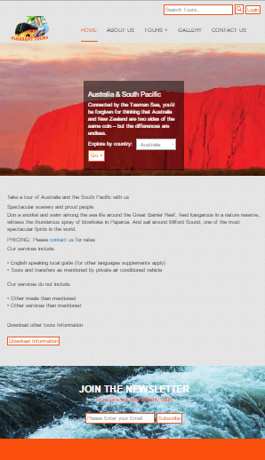

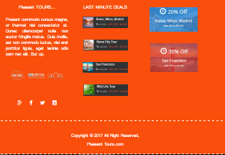

# STARTING OF “Africa PAGE”

<!doctype html>

<html>

<head>

<meta charset="utf-8">

<link rel="shortcut icon" href="img/favicon.ico">

<meta name="viewport" content="width=device-width, initial-scale=1, maximum-scale=1, , initial-scale=1.0">

<link rel="stylesheet" href="css/main_style.css">

<link rel="stylesheet" href="css/bootstrap.min.css">

<link rel="stylesheet" href="css/font-awesome.css">

<link rel="stylesheet" href="css/font-awesome.min.css">

<link rel="stylesheet" href="css/animate.css">

<link href="css/jquery-accordion-menu.css" rel="stylesheet" type="text/css" />

<link rel="stylesheet" type="text/css" href="engine1/style.css" />

<script type="text/javascript" src="engine1/jquery.js"></script>

<title>Pleasant Tours</title>

</head>

<body>

<div id="totop"></div>

<div class="login-btn text-right">

<div class="container">

<input type="search" placeholder="Search Tours.." class="tour-btn">

<a href="tour.html">

<span class="glyphicon glyphicon-search tour-btn search"></span>

</a>

<a href="admin.html" class="tour-btn">Login</a>

</div>

</div>

<header class="zind">

<div class="container">

<div class="col-xs-4 col-md-3">

<a href="">

<img src="img/logo.png" alt="">

</a>

</div>

<div class="col-xs-8 col-md-9">

<div id="fdw">

<!--nav-->

<nav>

<ul>

<li class="current">

<a href="index.html">home</a>

</li>

<li><a href="about.html">about us</a></li>

<li>

<a href="tour.html">Tours +<span class="arrow"></span></a>

<ul style="display: none;" class="sub_menu">

<li class="arrow_top"></li>

<li><a href="beach.html">BEACH TOUR</a></li>

<li><a href="hill.html">Hill Stations</a></li>

<li><a href="fort.html">Forts/Palaces</a></li>

<li><a href="south.html">SOUTH AMERICA</a></li>

<li><a href="australia.html">AUSTRALIA</a></li>

<li><a href="africa.html">AFRICA</a></li>

<li><a href="europe.html">EUROPE</a></li>

<li><a href="asia.html">ASIA</a></li>

</ul>

</li>

<li>

<a href="gallery.html">gallery</a>

</li>

<li><a href="contact.html">contact us</a></li>

</ul>

</nav>

</div>

</div>

</div>

</header>

<main>

<section class="africa-slider">

<div class="container">

<div class="tour-cen wow bounceInDown">

<h2>Africa & Middle East</h2>

<p>Take Africa's powerful natural world and the cultural contrasts of the Middle East, and you've got two regions like nowhere else on earth.</p>

<p class="js-module-view-all-trips">

<span class="tour-sel-h">Explore by country:</span>&nbsp;

<select class="tour-sel">

<option value="">Egypt</option>

<option value="">Turkey</option>

<option value="">Turkey</option>

<option value="">Israel</option>

<option value="">Jordan</option>

</select>

<a href="tour.html">

<button type="submit" class="tour-btn">

Go >

</button>

</a>

</p>

</div>

</div>

</section>

<br>

<br>

<section>

<div class="container wow zoomInDown">

<h3>Take a tour of Africa or the Middle East with us</h3>

<h3>From spectacular Rio to secretive ruins</h3>

<p>The raw, wild beauty of Africa is unsurpassable, and the Middle East is so richly diverse it's indefinable. Take in the mysterious towering pyramids of Egypt to the gargantuan, mustard-coloured dunes of the Sahara. And discover the lost city of Petra, home to Arab settlers more than 2,000 years ago.</p>

<br>

<br>

<p>When you come with us, you’ll have the opportunity to experience Jerusalem’s Wailing Wall. Meet the owner of a riad in Morocco, who’ll join you for a traditional meal made with piquant spices. In Turkey, enjoy the company of our Local Specialists who’ll tell you about the unique spiritual order of the Whirling Dervishes.</p>

<h3>PRICING: Please <a href="contact.html">contact us</a> for rates</h3>

<p>Our services include:<br><br>

• English speaking local guide (for other languages supplements apply)<br>

• Tours and transfers as mentioned by private air conditioned vehicle<br>

<br>

Our services do not include:<br>

<br>

• Other meals than mentioned<br>

• Other services than mentioned

</p><br>

<h3>Download other tours Information</h3><br>

<a href="download-file/america.docx" class="tour-btn">Download Information</a><br>

</div>

</section><br>

<br>

<br>

<section class="p1">

<div class="container text-center"><br>

<br>

<h2 class="join-heading">JOIN THE NEWSLETTER</h2>

<p style="color:#f94e0c;">To receive our best monthly deals </p><br>

<input class="tour-btn" required type="text" placeholder="Please Enter your Email">

<span>

<button class="tour-btn" onClick="subscribe()">Subscribe</button>

</span>

</div>

<br><br>

</section>

<section class="footer-top"><br>

<br>

<div class="container">

<div class="col-md-4 text-center"><br>

<h3>Pleasant TOURS...</h3><br>

<p class="text-justify">Present commodo cursus magna, or thermal nisl consectetur et. Donec ullamcorper nulla non auctor fringilla metus. Duis mollis, est non commodo luctus, nisi erat porttitor ligula, eget lacinia odio sem nec elit. But up.</p><br>

<br>

<img src="img/14.png">

<br><br>

<br>

<br>

<a href="https://www.facebook.com/Mohammad-Humayun-1128144880554699/" target="_blank"><i class="fa fa-google-plus icon"></i></a>

<a href="https://www.facebook.com/Mohammad-Humayun-1128144880554699/" target="_blank"><i class="fa fa-facebook icon"></i></a>

<a href="https://www.facebook.com/Mohammad-Humayun-1128144880554699/" target="_blank">

<i class="fa fa-twitter icon"></i></a>

<a href="https://www.facebook.com/Mohammad-Humayun-1128144880554699/" target="_blank">

<i class="fa fa-instagram icon"></i></a>

</div>

<div class="col-md-4 text-center"><br>

<h3>LAST MINUTE DEALS</h3><br>

<a href=""><img src="img/15.jpg"></a><br><br>

<br>

<a href=""><img src="img/16.jpg"></a><br><br><br>

<a href=""><img src="img/17.jpg"></a><br><br><br>

<a href=""><img src="img/18.jpg"></a><br><br><br>

</div>

<div class="col-md-4 text-center"><br>

<br>

<a href=""><img src="img/19.jpg"></a><br><br><br>

<a href=""><img src="img/20.jpg"></a>

</div>

</div><br>

<br>

</section>

</main>

<footer class="footer-top text-center"><br>

<div class="container"><br>

<p>Copyright &copy; 2017 All Right Reserved, <h3><a href="http://humayun-portfolio.firebaseapp.com/" target="_blank">Pleasant Tours.com</a></h3></p>

<br>

</div>

</footer>

<script src="js/jquery-3.1.0.min.js"></script>

<script src="js/bootstrap.min.js"></script>

<script src="js/sscroll.js"></script>

<script src="js/Totop.js"></script>

<script src="js/wow.js"></script>

<script>

new WOW().init();

</script>

<script src="js/index.js"></script>

<script src="js/jquery-1.11.2.min.js" type="text/javascript"></script>

<script src="js/jquery-accordion-menu.js" type="text/javascript"></script>

<script type="text/javascript" src="engine1/wowslider.js"></script>

<script type="text/javascript" src="engine1/script.js"></script>

</body>

</html>

***END OF “Africa PAGE”***

# SCREEN SHOT OF “Africa PAGE”

# 

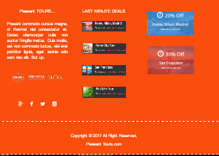

# STARTING OF “EUROPE PAGE”

<!doctype html>

<html>

<head>

<meta charset="utf-8">

<link rel="shortcut icon" href="img/favicon.ico">

<meta name="viewport" content="width=device-width, initial-scale=1, maximum-scale=1, , initial-scale=1.0">

<link rel="stylesheet" href="css/main_style.css">

<link rel="stylesheet" href="css/bootstrap.min.css">

<link rel="stylesheet" href="css/font-awesome.css">

<link rel="stylesheet" href="css/font-awesome.min.css">

<link rel="stylesheet" href="css/animate.css">

<link href="css/jquery-accordion-menu.css" rel="stylesheet" type="text/css" />

<link rel="stylesheet" type="text/css" href="engine1/style.css" />

<script type="text/javascript" src="engine1/jquery.js"></script>

<title>Pleasant Tours</title>

</head>

<body>

<div id="totop"></div>

<div class="login-btn text-right">

<div class="container">

<input type="search" placeholder="Search Tours.." class="tour-btn">

<a href="tour.html">

<span class="glyphicon glyphicon-search tour-btn search"></span>

</a>

<a href="admin.html" class="tour-btn">Login</a>

</div>

</div>

<header class="zind">

<div class="container">

<div class="col-xs-4 col-md-3">

<a href="">

<img src="img/logo.png" alt="">

</a>

</div>

<div class="col-xs-8 col-md-9">

<div id="fdw">

<!--nav-->

<nav>

<ul>

<li class="current">

<a href="index.html">home</a>

</li>

<li><a href="about.html">about us</a></li>

<li>

<a href="tour.html">Tours +<span class="arrow"></span></a>

<ul style="display: none;" class="sub_menu">

<li class="arrow_top"></li>

<li><a href="beach.html">BEACH TOUR</a></li>

<li><a href="hill.html">Hill Stations</a></li>

<li><a href="fort.html">Forts/Palaces</a></li>

<li><a href="south.html">SOUTH AMERICA</a></li>

<li><a href="australia.html">AUSTRALIA</a></li>

<li><a href="africa.html">AFRICA</a></li>

<li><a href="europe.html">EUROPE</a></li>

<li><a href="asia.html">ASIA</a></li>

</ul>

</li>

<li>

<a href="gallery.html">gallery</a>

</li>

<li><a href="contact.html">contact us</a></li>

</ul>

</nav>

</div>

</div>

</div>

</header>

<main>

<section class="europe-slider">

<div class="container">

<div class="tour-cen wow jello">

<h2>Europe</h2>

<p>From Her Majesty's Royal Palace and Fortress in London to the ancient city of Pompeii, Europe represents a journey through two thousand years of history, culture and heritage.</p>

<p class="js-module-view-all-trips">

<span class="tour-sel-h">Explore by country:</span>&nbsp;

<select class="tour-sel">

<option value="">Austria</option>

<option value="">Belarus</option>

<option value="">Chile</option>

<option value="">Ecuador</option>

<option value="">Peru</option>

</select>

<a href="tour.html">

<button type="submit" class="tour-btn">

Go >

</button>

</a>

</p>

</div>

</div>

</section>

<br>

<br>

<section>

<div class="container wow jello">

<h3>Take a tour of Europe</h3>

<h3>And discover Europe for yourself</h3>

<p>We’ll immerse you in the sights, sounds and sensations of some of Europe’s most iconic locations. But we’ll also introduce you to experiences few travellers have the chance to enjoy. Climb Bramante's spiral staircase in the Vatican, normally out of bounds to the general public. Or join us for authentic local dishes with Beatrice, the charming owner of an elegant 17th century château in Villandry, France. </p>

<h3>PRICING: Please <a href="contact.html">contact us</a> for rates</h3>

<p>Our services include:<br><br>

• English speaking local guide (for other languages supplements apply)<br>

• Tours and transfers as mentioned by private air conditioned vehicle<br>

<br>

Our services do not include:<br>

<br>

• Other meals than mentioned<br>

• Other services than mentioned

</p><br>

<h3>Download other tours Information</h3><br>

<a href="download-file/america.docx" class="tour-btn">Download Information</a><br>

</div>

</section><br>

<br>

<br>

<section class="p1">

<div class="container text-center"><br>

<br>

<h2 class="join-heading">JOIN THE NEWSLETTER</h2>

<p style="color:#f94e0c;">To receive our best monthly deals </p><br>

<input class="tour-btn" required type="text" placeholder="Please Enter your Email">

<span>

<button class="tour-btn" onClick="subscribe()">Subscribe</button>

</span>

</div>

<br><br>

</section>

<section class="footer-top"><br>

<br>

<div class="container">

<div class="col-md-4 text-center"><br>

<h3>Pleasant TOURS...</h3><br>

<p class="text-justify">Present commodo cursus magna, or thermal nisl consectetur et. Donec ullamcorper nulla non auctor fringilla metus. Duis mollis, est non commodo luctus, nisi erat porttitor ligula, eget lacinia odio sem nec elit. But up.</p><br>

<br>

<img src="img/14.png">

<br><br>

<br>

<br>

<a href="https://www.facebook.com/Mohammad-Humayun-1128144880554699/" target="_blank"><i class="fa fa-google-plus icon"></i></a>

<a href="https://www.facebook.com/Mohammad-Humayun-1128144880554699/" target="_blank"><i class="fa fa-facebook icon"></i></a>

<a href="https://www.facebook.com/Mohammad-Humayun-1128144880554699/" target="_blank">

<i class="fa fa-twitter icon"></i></a>

<a href="https://www.facebook.com/Mohammad-Humayun-1128144880554699/" target="_blank">

<i class="fa fa-instagram icon"></i></a>

</div>

<div class="col-md-4 text-center"><br>

<h3>LAST MINUTE DEALS</h3><br>

<a href=""><img src="img/15.jpg"></a><br><br>

<br>

<a href=""><img src="img/16.jpg"></a><br><br><br>

<a href=""><img src="img/17.jpg"></a><br><br><br>

<a href=""><img src="img/18.jpg"></a><br><br><br>

</div>

<div class="col-md-4 text-center"><br>

<br>

<a href=""><img src="img/19.jpg"></a><br><br><br>

<a href=""><img src="img/20.jpg"></a>

</div>

</div><br>

<br>

</section>

</main>

<footer class="footer-top text-center"><br>

<div class="container"><br>

<p>Copyright &copy; 2017 All Right Reserved, <h3><a href="http://humayun-portfolio.firebaseapp.com/" target="_blank">Pleasant Tours.com</a></h3></p>

<br>

</div>

</footer>

<script src="js/jquery-3.1.0.min.js"></script>

<script src="js/bootstrap.min.js"></script>

<script src="js/sscroll.js"></script>

<script src="js/Totop.js"></script>

<script src="js/wow.js"></script>

<script>

new WOW().init();

</script>

<script src="js/index.js"></script>

<script src="js/jquery-1.11.2.min.js" type="text/javascript"></script>

<script src="js/jquery-accordion-menu.js" type="text/javascript"></script>

<script type="text/javascript" src="engine1/wowslider.js"></script>

<script type="text/javascript" src="engine1/script.js"></script>

</body>

</html>

***END OF “EUROPE PAGE”***

# SCREEN SHOT OF “EUROPE PAGE”

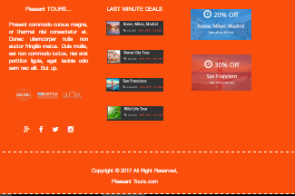

# STARTING OF “ASIA PAGE”

<!doctype html>

<html>

<head>

<meta charset="utf-8">

<link rel="shortcut icon" href="img/favicon.ico">

<meta name="viewport" content="width=device-width, initial-scale=1, maximum-scale=1, , initial-scale=1.0">

<link rel="stylesheet" href="css/main_style.css">

<link rel="stylesheet" href="css/bootstrap.min.css">

<link rel="stylesheet" href="css/font-awesome.css">

<link rel="stylesheet" href="css/font-awesome.min.css">

<link rel="stylesheet" href="css/animate.css">

<link href="css/jquery-accordion-menu.css" rel="stylesheet" type="text/css" />

<link rel="stylesheet" type="text/css" href="engine1/style.css" />

<script type="text/javascript" src="engine1/jquery.js"></script>

<title>M.H Tours</title>

</head>

<body>

<div id="totop"></div>

<div class="login-btn text-right">

<div class="container">

<input type="search" placeholder="Search Tours.." class="tour-btn">

<a href="tour.html">

<span class="glyphicon glyphicon-search tour-btn search"></span>

</a>

<a href="admin.html" class="tour-btn">Login</a>

</div>

</div>

<header class="zind">

<div class="container">

<div class="col-xs-4 col-md-3">

<a href="">

<img src="img/logo.png" alt="">

</a>

</div>

<div class="col-xs-8 col-md-9">

<div id="fdw">

<!--nav-->

<nav>

<ul>

<li class="current">

<a href="index.html">home</a>

</li>

<li><a href="about.html">about us</a></li>

<li>

<a href="tour.html">Tours +<span class="arrow"></span></a>

<ul style="display: none;" class="sub_menu">

<li class="arrow_top"></li>

<li><a href="beach.html">BEACH TOUR</a></li>

<li><a href="hill.html">Hill Stations</a></li>

<li><a href="fort.html">Forts/Palaces</a></li>

<li><a href="south.html">SOUTH AMERICA</a></li>

<li><a href="australia.html">AUSTRALIA</a></li>

<li><a href="africa.html">AFRICA</a></li>

<li><a href="europe.html">EUROPE</a></li>

<li><a href="asia.html">ASIA</a></li>

</ul>

</li>

<li>

<a href="gallery.html">gallery</a>

</li>

<li><a href="contact.html">contact us</a></li>

</ul>

</nav>

</div>

</div>

</div>

</header>

<main>

<section class="asia-slider">

<div class="container">

<div class="tour-cen wow bounceIn">

<h2>Asia</h2>

<p>The world’s largest continent is indefinable and enigmatic, which is just what makes Asia so irresistible.</p>

<p class="js-module-view-all-trips">

<span class="tour-sel-h">Explore by country:</span>&nbsp;

<select class="tour-sel">

<option value="">Pakistan</option>

<option value="">Asia Stopover</option>

<option value="">China</option>

<option value="">Japan</option>

<option value="">India</option>

</select>

<a href="tour.html">

<button type="submit" class="tour-btn">

Go >

</button>

</a>

</p>

</div>

</div>

</section>

<br>

<br>

<section>

<div class="container wow bounceInRight">

<h3>Discover Asia on our award-winning tours</h3>

<h3>Mystery, myths and spirituality</h3>

<p>The mysteries and myths of Asia have fascinated Europeans for centuries. The spiritual continent is full of ancient wonders, such as the enormous Buddhas of Thailand and the Forbidden City in Beijing. </p>

<h3>PRICING: Please <a href="contact.html">contact us</a> for rates</h3>

<p>Our services include:<br><br>

• English speaking local guide (for other languages supplements apply)<br>

• Tours and transfers as mentioned by private air conditioned vehicle<br>

<br>

Our services do not include:<br>

<br>

• Other meals than mentioned<br>

• Other services than mentioned

</p><br>

<h3>Download other tours Information</h3><br>

<a href="download-file/america.docx" class="tour-btn">Download Information</a><br>

</div>

</section><br>

<br>

<br>

<section class="p1">

<div class="container text-center"><br>

<br>

<h2 class="join-heading">JOIN THE NEWSLETTER</h2>

<p style="color:#f94e0c;">To receive our best monthly deals </p><br>

<input class="tour-btn" required type="text" placeholder="Please Enter your Email">

<span>

<button class="tour-btn" onClick="subscribe()">Subscribe</button>

</span>

</div>

<br><br>

</section>

<section class="footer-top"><br>

<br>

<div class="container">

<div class="col-md-4 text-center"><br>

<h3>Pleasant TOURS...</h3><br>

<p class="text-justify">Present commodo cursus magna, or thermal nisl consectetur et. Donec ullamcorper nulla non auctor fringilla metus. Duis mollis, est non commodo luctus, nisi erat porttitor ligula, eget lacinia odio sem nec elit. But up.</p><br>

<br>

<img src="img/14.png">

<br><br>

<br>

<br>

<a href="https://www.facebook.com/Mohammad-Humayun-1128144880554699/" target="_blank"><i class="fa fa-google-plus icon"></i></a>

<a href="https://www.facebook.com/Mohammad-Humayun-1128144880554699/" target="_blank"><i class="fa fa-facebook icon"></i></a>

<a href="https://www.facebook.com/Mohammad-Humayun-1128144880554699/" target="_blank">

<i class="fa fa-twitter icon"></i></a>

<a href="https://www.facebook.com/Mohammad-Humayun-1128144880554699/" target="_blank">

<i class="fa fa-instagram icon"></i></a>

</div>

<div class="col-md-4 text-center"><br>

<h3>LAST MINUTE DEALS</h3><br>

<a href=""><img src="img/15.jpg"></a><br><br>

<br>

<a href=""><img src="img/16.jpg"></a><br><br><br>

<a href=""><img src="img/17.jpg"></a><br><br><br>

<a href=""><img src="img/18.jpg"></a><br><br><br>

</div>

<div class="col-md-4 text-center"><br>

<br>

<a href=""><img src="img/19.jpg"></a><br><br><br>

<a href=""><img src="img/20.jpg"></a>

</div>

</div><br>

<br>

</section>

</main>

<footer class="footer-top text-center"><br>

<div class="container"><br>

<p>Copyright &copy; 2017 All Right Reserved, <h3><a href="http://humayun-portfolio.firebaseapp.com/" target="_blank">Pleasant Tours.com</a></h3></p>

<br>

</div>

</footer>

<script src="js/jquery-3.1.0.min.js"></script>

<script src="js/bootstrap.min.js"></script>

<script src="js/sscroll.js"></script>

<script src="js/Totop.js"></script>

<script src="js/wow.js"></script>

<script>

new WOW().init();

</script>

<script src="js/index.js"></script>

<script src="js/jquery-1.11.2.min.js" type="text/javascript"></script>

<script src="js/jquery-accordion-menu.js" type="text/javascript"></script>

<script type="text/javascript" src="engine1/wowslider.js"></script>

<script type="text/javascript" src="engine1/script.js"></script>

</body>

</html>

***END OF “ASIA PAGE”***

# SCREEN SHOT OF “ASIA PAGE”

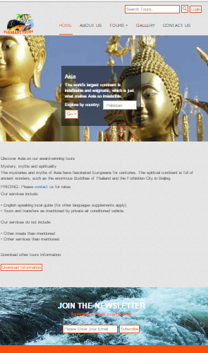

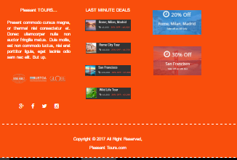

# STARTING OF “GALLERY PAGE”

<!doctype html>

<html>

<head>

<meta charset="utf-8">

<link rel="shortcut icon" href="img/favicon.ico">

<meta name="viewport" content="width=device-width, initial-scale=1, maximum-scale=1, , initial-scale=1.0">

<link rel="stylesheet" href="css/main_style.css">

<link rel="stylesheet" href="css/bootstrap.min.css">

<link rel="stylesheet" href="css/font-awesome.css">

<link rel="stylesheet" href="css/font-awesome.min.css">

<link rel="stylesheet" href="css/animate.css">

<link href="css/jquery-accordion-menu.css" rel="stylesheet" type="text/css" />

<link rel="stylesheet" type="text/css" href="engine1/style.css" />

<script type="text/javascript" src="engine1/jquery.js"></script>

<title>Pleasant Tours</title>

</head>

<body>

<div id="totop"></div>

<div class="login-btn text-right">

<div class="container">

<input type="search" placeholder="Search Tours.." class="tour-btn">

<a href="tour.html">

<span class="glyphicon glyphicon-search tour-btn search"></span>

</a>

<a href="admin.html" class="tour-btn">Login</a>

</div>

</div>

<header class="zind">

<div class="container">

<div class="col-xs-4 col-md-3">

<a href="">

<img src="img/logo.png" alt="">

</a>

</div>

<div class="col-xs-8 col-md-9">

<div id="fdw">

<!--nav-->

<nav>

<ul>

<li class="current">

<a href="index.html">home</a>

</li>

<li><a href="about.html">about us</a></li>

<li>

<a href="tour.html">Tours +<span class="arrow"></span></a>

<ul style="display: none;" class="sub_menu">

<li class="arrow_top"></li>

<li><a href="beach.html">BEACH TOUR</a></li>

<li><a href="hill.html">Hill Stations</a></li>

<li><a href="fort.html">Forts/Palaces</a></li>

<li><a href="south.html">SOUTH AMERICA</a></li>

<li><a href="australia.html">AUSTRALIA</a></li>

<li><a href="africa.html">AFRICA</a></li>

<li><a href="europe.html">EUROPE</a></li>

<li><a href="asia.html">ASIA</a></li>

</ul>

</li>

<li>

<a href="gallery.html">gallery</a>

</li>

<li><a href="contact.html">contact us</a></li>

</ul>

</nav>

</div>

</div>

</div>

</header>

<main><br>

<br>

<section>

<div class="container">

<ul class="lb-album">

<li>

<a href="#image-1">

<img src="img/gallery/1.jpg" alt="image01">

<span>Pleasant Tours</span>

</a>

<div class="lb-overlay" id="image-1">

<img src="img/gallery/1.jpg" alt="image01" />

<div>

<h3>Pleasant Tours </h3>

<p>

Pleasant Tours is the perfect choice for you to visit nearby floating markets, the major draw for tourists who come here to boat along the many canals and rivers leading out of town.</p>

</div>

<a href="#page" class="lb-close">X Close</a>

</div>

</li>

<li>

<a href="#image-2">

<img src="img/gallery/2.jpg" alt="image01">

<span>Pleasant Tours</span>

</a>

<div class="lb-overlay" id="image-2">

<img src="img/gallery/2.jpg" alt="image01" />

<div>

<h3>Pleasant Tours </h3>

<p>

Pleasant Tours is the perfect choice for you to visit nearby floating markets, the major draw for tourists who come here to boat along the many canals and rivers leading out of town.</p>

</div>

<a href="#page" class="lb-close">X Close</a>

</div>

</li>

<li>

<a href="#image-3">

<img src="img/gallery/3.jpg" alt="image01">

<span>Pleasant Tours</span>

</a>

<div class="lb-overlay" id="image-3">

<img src="img/gallery/3.jpg" alt="image01" />

<div>

<h3>Pleasant Tours </h3>

<p>

Pleasant Tours is the perfect choice for you to visit nearby floating markets, the major draw for tourists who come here to boat along the many canals and rivers leading out of town.</p>

</div>

<a href="#page" class="lb-close">X Close</a>

</div>

</li>

<li>

<a href="#image-4">

<img src="img/gallery/4.jpg" alt="image01">

<span>Pleasant Tours</span>

</a>

<div class="lb-overlay" id="image-4">

<img src="img/gallery/4.jpg" alt="image01" />

<div>

<h3>Pleasant Tours </h3>

<p>

Pleasant Tours is the perfect choice for you to visit nearby floating markets, the major draw for tourists who come here to boat along the many canals and rivers leading out of town.</p>

</div>

<a href="#page" class="lb-close">X Close</a>

</div>

</li>

<li>

<a href="#image-5">

<img src="img/gallery/5.jpg" alt="image01">

<span>Pleasant Tours</span>

</a>

<div class="lb-overlay" id="image-5">

<img src="img/gallery/5.jpg" alt="image01" />

<div>

<h3>Pleasant Tours </h3>

<p>

Pleasant Tours is the perfect choice for you to visit nearby floating markets, the major draw for tourists who come here to boat along the many canals and rivers leading out of town.</p>

</div>

<a href="#page" class="lb-close">X Close</a>

</div>

</li>

<li>

<a href="#image-6">

<img src="img/gallery/6.jpg" alt="image01">

<span>Pleasant Tours</span>

</a>

<div class="lb-overlay" id="image-6">

<img src="img/gallery/6.jpg" alt="image01" />

<div>

<h3>Pleasant Tours </h3>

<p>

Pleasant Tours is the perfect choice for you to visit nearby floating markets, the major draw for tourists who come here to boat along the many canals and rivers leading out of town.</p>

</div>

<a href="#page" class="lb-close">X Close</a>

</div>

</li>

<li>

<a href="#image-7">

<img src="img/gallery/7.jpg" alt="image01">

<span>Pleasant Tours</span>

</a>

<div class="lb-overlay" id="image-7">

<img src="img/gallery/7.jpg" alt="image01" />

<div>

<h3>Pleasant Tours </h3>

<p>

Pleasant Tours is the perfect choice for you to visit nearby floating markets, the major draw for tourists who come here to boat along the many canals and rivers leading out of town.</p>

</div>

<a href="#page" class="lb-close">XClose</a>

</div>

</li>

<li>

<a href="#image-8">

<img src="img/gallery/8.jpg" alt="image01">

<span>Pleasant Tours</span>

</a>

<div class="lb-overlay" id="image-8">

<img src="img/gallery/8.jpg" alt="image01" />

<div>

<h3>Pleasant Tours </h3>

<p>

Pleasant Tours is the perfect choice for you to visit nearby floating markets, the major draw for tourists who come here to boat along the many canals and rivers leading out of town.</p>

</div>

<a href="#page" class="lb-close">X Close</a>

</div>

</li>

<li>

<a href="#image-9">

<img src="img/gallery/9.jpg" alt="image01">

<span>Pleasant Tours</span>

</a>

<div class="lb-overlay" id="image-9">

<img src="img/gallery/9.jpg" alt="image01" />

<div>

<h3>Pleasant Tours </h3>

<p>

Pleasant Tours is the perfect choice for you to visit nearby floating markets, the major draw for tourists who come here to boat along the many canals and rivers leading out of town.</p>

</div>

<a href="#page" class="lb-close">X Close</a>

</div>

</li>

<li>

<a href="#image-10">

<img src="img/gallery/10.jpg" alt="image01">

<span>Pleasant Tours</span>

</a>

<div class="lb-overlay" id="image-10">

<img src="img/gallery/10.jpg" alt="image01" />

<div>

<h3>Pleasant Tours </h3>

<p>

Pleasant Tours is the perfect choice for you to visit nearby floating markets, the major draw for tourists who come here to boat along the many canals and rivers leading out of town.</p>

</div>

<a href="#page" class="lb-close">X Close</a>

</div>

</li>

<li>

<a href="#image-11">

<img src="img/gallery/11.jpg" alt="image01">

<span>Pleasant Tours</span>

</a>

<div class="lb-overlay" id="image-11">

<img src="img/gallery/11.jpg" alt="image01" />

<div>

<h3>Pleasant Tours </h3>

<p>

Pleasant Tours is the perfect choice for you to visit nearby floating markets, the major draw for tourists who come here to boat along the many canals and rivers leading out of town.</p>

</div>

<a href="#page" class="lb-close">X Close</a>

</div>

</li>

<li>

<a href="#image-12">

<img src="img/gallery/12.jpg" alt="image01">

<span>Pleasant Tours</span>

</a>

<div class="lb-overlay" id="image-12">

<img src="img/gallery/12.jpg" alt="image01" />

<div>

<h3>Pleasant Tours </h3>

<p>

Pleasant Tours is the perfect choice for you to visit nearby floating markets, the major draw for tourists who come here to boat along the many canals and rivers leading out of town.</p>

</div>

<a href="#page" class="lb-close">X Close</a>

</div>

</li>

<li>

<a href="#image-13">

<img src="img/gallery/13.jpg" alt="image01">

<span>Pleasant Tours</span>

</a>

<div class="lb-overlay" id="image-13">

<img src="img/gallery/13.jpg" alt="image01" />

<div>

<h3>Pleasant Tours </h3>

<p>

Pleasant Tours is the perfect choice for you to visit nearby floating markets, the major draw for tourists who come here to boat along the many canals and rivers leading out of town.</p>

</div>

<a href="#page" class="lb-close">X Close</a>

</div>

</li>

<li>

<a href="#image-14">

<img src="img/gallery/14.jpg" alt="image01">

<span>Pleasant Tours</span>

</a>

<div class="lb-overlay" id="image-14">

<img src="img/gallery/14.jpg" alt="image01" />

<div>

<h3>Pleasant Tours </h3>

<p>

Pleasant Tours is the perfect choice for you to visit nearby floating markets, the major draw for tourists who come here to boat along the many canals and rivers leading out of town.</p>

</div>

<a href="#page" class="lb-close">X Close</a>

</div>

</li>

<li>

<a href="#image-15">

<img src="img/gallery/15.jpg" alt="image01">

<span>Pleasant Tours</span>

</a>

<div class="lb-overlay" id="image-15">

<img src="img/gallery/15.jpg" alt="image01" />

<div>

<h3>Pleasant Tours </h3>

<p>

Pleasant Tours is the perfect choice for you to visit nearby floating markets, the major draw for tourists who come here to boat along the many canals and rivers leading out of town.</p>

</div>

<a href="#page" class="lb-close">XClose</a>

</div>

</li>

<li>

<a href="#image-16">

<img src="img/gallery/16.jpg" alt="image01">

<span>Pleasant Tours</span>

</a>

<div class="lb-overlay" id="image-16">

<img src="img/gallery/16.jpg" alt="image01" />

<div>

<h3>Pleasant Tours </h3>

<p>

Pleasant Tours is the perfect choice for you to visit nearby floating markets, the major draw for tourists who come here to boat along the many canals and rivers leading out of town.</p>

</div>

<a href="#page" class="lb-close">X Close</a>

</div>

</li>

<li>

<a href="#image-1">

<img src="img/gallery/1.jpg" alt="image01">

<span>Pleasant Tours</span>

</a>

<div class="lb-overlay" id="image-1">

<img src="img/gallery/1.jpg" alt="image01" />

<div>

<h3>Pleasant Tours </h3>

<p>

Pleasant Tours is the perfect choice for you to visit nearby floating markets, the major draw for tourists who come here to boat along the many canals and rivers leading out of town.</p>

</div>

<a href="#page" class="lb-close">X Close</a>

</div>

</li>

<li>

<a href="#image-2">

<img src="img/gallery/2.jpg" alt="image01">

<span>Pleasant Tours</span>

</a>

<div class="lb-overlay" id="image-2">

<img src="img/gallery/2.jpg" alt="image01" />

<div>

<h3>Pleasant Tours </h3>

<p>

Pleasant Tours is the perfect choice for you to visit nearby floating markets, the major draw for tourists who come here to boat along the many canals and rivers leading out of town.</p>

</div>

<a href="#page" class="lb-close">X Close</a>

</div>

</li>

</ul>

</div>

</section>

<br>

<br>

<br>

<section class="footer-top"><br>

<br>

<div class="container">

<div class="col-md-4 text-center"><br>

<h3>Pleasant TOURS...</h3><br>

<p class="text-justify">Present commodo cursus magna, or thermal nisl consectetur et. Donec ullamcorper nulla non auctor fringilla metus. Duis mollis, est non commodo luctus, nisi erat porttitor ligula, eget lacinia odio sem nec elit. But up.</p><br>

<br>

<img src="img/14.png" alt="image">

<br><br>

<br>

<br>

<a href="https://www.facebook.com/Mohammad-Humayun-1128144880554699/" target="_blank"><i class="fa fa-google-plus icon"></i></a>

<a href="https://www.facebook.com/Mohammad-Humayun-1128144880554699/" target="_blank"><i class="fa fa-facebook icon"></i></a>

<a href="https://www.facebook.com/Mohammad-Humayun-1128144880554699/" target="_blank">

<i class="fa fa-twitter icon"></i></a>

<a href="https://www.facebook.com/Mohammad-Humayun-1128144880554699/" target="_blank">

<i class="fa fa-instagram icon"></i></a>

</div>

<div class="col-md-4 text-center"><br>

<h3>LAST MINUTE DEALS</h3><br>

<a href=""><img src="img/15.jpg" alt="image"></a><br><br>

<br>

<a href=""><img src="img/16.jpg" alt="image"></a><br><br><br>

<a href=""><img src="img/17.jpg" alt="image"></a><br><br><br>

<a href=""><img src="img/18.jpg"></a><br><br><br>

</div>

<div class="col-md-4 text-center"><br>

<br>

<a href=""><img src="img/19.jpg" alt="image"></a><br><br><br>

<a href=""><img src="img/20.jpg" alt="image"></a>

</div>

</div><br>

<br>

</section>

</main>

<footer class="footer-top text-center"><br>

<div class="container"><br>

<p>Copyright &copy; 2017 All Right Reserved, <h3><a href="http://humayun-portfolio.firebaseapp.com/" target="_blank">Pleasant Tours.com</a></h3></p>

<br>

</div>

</footer>

<script src="js/jquery-3.1.0.min.js"></script>

<script src="js/bootstrap.min.js"></script>

<script src="js/sscroll.js"></script>

<script src="js/Totop.js"></script>

<script src="js/wow.js"></script>

<script>

new WOW().init();

</script>

<script src="js/index.js"></script>

<script src="js/jquery-1.11.2.min.js" type="text/javascript"></script>

<script src="js/jquery-accordion-menu.js" type="text/javascript"></script>

<script type="text/javascript" src="engine1/wowslider.js"></script>

<script type="text/javascript" src="engine1/script.js"></script>

</body>

</html>

***END OF “GALLERY PAGE”***

# SCREEN SHOT OF “GALLERY PAGE”

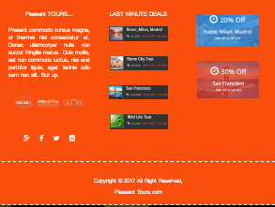

# STARTING OF “CONTACT US PAGE”

<!doctype html>

<html>

<head>

<meta charset="utf-8">

<link rel="shortcut icon" href="img/favicon.ico">

<meta name="viewport" content="width=device-width, initial-scale=1, maximum-scale=1, , initial-scale=1.0">

<link rel="stylesheet" href="css/main_style.css">

<link rel="stylesheet" href="css/bootstrap.min.css">

<link rel="stylesheet" href="css/font-awesome.css">

<link rel="stylesheet" href="css/font-awesome.min.css">

<link rel="stylesheet" href="css/animate.css">

<link href="css/jquery-accordion-menu.css" rel="stylesheet" type="text/css" />

<link rel="stylesheet" type="text/css" href="engine1/style.css" />

<script type="text/javascript" src="engine1/jquery.js"></script>

<title>Pleasant Tours</title>

</head>

<body>

<div id="totop"></div>

<div class="login-btn text-right">

<div class="container">

<input type="search" placeholder="Search Tours.." class="tour-btn">

<a href="tour.html">

<span class="glyphicon glyphicon-search tour-btn search"></span>

</a>

<a href="admin.html" class="tour-btn">Login</a>

</div>

</div>

<header class="zind">

<div class="container">

<div class="col-xs-4 col-md-3">

<a href="">

<img src="img/logo.png" alt="">

</a>

</div>

<div class="col-xs-8 col-md-9">

<div id="fdw">

<!--nav-->

<nav>

<ul>

<li class="current">

<a href="index.html">home</a>

</li>

<li><a href="about.html">about us</a></li>

<li>

<a href="tour.html">Tours +<span class="arrow"></span></a>

<ul style="display: none;" class="sub_menu">

<li class="arrow_top"></li>

<li><a href="beach.html">BEACH TOUR</a></li>

<li><a href="hill.html">Hill Stations</a></li>

<li><a href="fort.html">Forts/Palaces</a></li>

<li><a href="south.html">SOUTH AMERICA</a></li>

<li><a href="australia.html">AUSTRALIA</a></li>

<li><a href="africa.html">AFRICA</a></li>

<li><a href="europe.html">EUROPE</a></li>

<li><a href="asia.html">ASIA</a></li>

</ul>

</li>

<li>

<a href="gallery.html">gallery</a>

</li>

<li><a href="contact.html">contact us</a></li>

</ul>

</nav>

</div>

</div>

</div>

</header>

<main>

<section><br>

<div class="container text-center">

<h2 class="h2-heading">CONTACT US</h2>

<h3 class="h2-heading">CONTACT INFORMATION</h3>

<br>

<br>

</div>

</section>

<div id="map"></div>

<br>

<br>

<section class="info">

<div class="container">

<div class="col-md-6">

<h2 class="h2-heading">Pleasant Tours</h2>

<p>We're always interested in our customers' comments and thoughts about our products and services. Your feedback helps us to improve the site and serve you better. We want to make it as easy as possible for you to find us, so we've listed every possible way for you to get in touch..</p>

<h4 class="h2-heading">PLESANT TOURS.</h4>

<h4>Karachi,</h4>

<h4>Pakistan.</h4>

<h5>Call Now: +923128617796</h5>

<h5>Call Now: +923118050991</h5>

<h5>Whatsapp: +923128617796</h5>

<h5>Email:<a href="mailto:mohammadhumayun4u@gmail.com">mohammadhumayun4u@gmail.com</a></h5>

<h5>Email:<a href="mailto:mohammadhumayun4u@gmail.com">waqararif111@gmail.com</a></h5>

<h5>Email:<a href="mailto:mohammadhumayun4u@gmail.com">aminossama234@gmail.com</a></h5><br>

<br>

<a href="admin.html" class="tour-btn">Login Now</a>

</div>

<!--close info1-->

<div class="col-md-6">

<h2 class="h2-heading">CONTACT FORM</h2>

<form class="form" enctype="text/plain" method="post" action="mailto:mohammadhumayun4u@gmail.com">

<span>Your Name (required)</span> <br>

<input type="text" required name="Name" placeholder="Enter your Name"/>

<br>

<span>Your Email (required)</span> <br>

<input type="email" required name="Email" placeholder="Enter your Email"/>

<br>

<span>Subject</span> <br>

<input type="text" required name="Subject" placeholder="Enter your Subject"/>

<br>

<span>Your Message</span> <br>

<textarea rows="15" cols="70" name="Mesage"></textarea><br>

<br>

<input type="submit" class="tour-btn" value="send"/>

</form>

</div>

<!--close info2-->

</div>

</section>

<br>

<br>

<br>

<section class="footer-top"><br>

<br>

<div class="container">

<div class="col-md-4 text-center"><br>

<h3>PLEASANT TOURS...</h3><br>

<p class="text-justify">Present commodo cursus magna, or thermal nisl consectetur et. Donec ullamcorper nulla non auctor fringilla metus. Duis mollis, est non commodo luctus, nisi erat porttitor ligula, eget lacinia odio sem nec elit. But up.</p><br>

<br>

<img src="img/14.png" alt="image">

<br><br>

<br>

<br>

<a href="https://www.facebook.com/Mohammad-Humayun-1128144880554699/" target="_blank"><i class="fa fa-google-plus icon"></i></a>

<a href="https://www.facebook.com/Mohammad-Humayun-1128144880554699/" target="_blank"><i class="fa fa-facebook icon"></i></a>

<a href="https://www.facebook.com/Mohammad-Humayun-1128144880554699/" target="_blank">

<i class="fa fa-twitter icon"></i></a>

<a href="https://www.facebook.com/Mohammad-Humayun-1128144880554699/" target="_blank">

<i class="fa fa-instagram icon"></i></a>

</div>

<div class="col-md-4 text-center"><br>

<h3>LAST MINUTE DEALS</h3><br>

<a href=""><img src="img/15.jpg" alt="image"></a><br><br>

<br>

<a href=""><img src="img/16.jpg" alt="image"></a><br><br><br>

<a href=""><img src="img/17.jpg" alt="image"></a><br><br><br>

<a href=""><img src="img/18.jpg"></a><br><br><br>

</div>

<div class="col-md-4 text-center"><br>

<br>

<a href=""><img src="img/19.jpg" alt="image"></a><br><br><br>

<a href=""><img src="img/20.jpg" alt="image"></a>

</div>

</div><br>

<br>

</section>

</main>

<footer class="footer-top text-center"><br>

<div class="container"><br>

<p>Copyright &copy; 2017 All Right Reserved,

<h3><a href="http://humayun-portfolio.firebaseapp.com/" target="_blank">Pleasant Tours.com</a></h3>

</p>

<br>

</div>

</footer>

<script src="js/jquery-3.1.0.min.js"></script>

<script src="js/bootstrap.min.js"></script>

<script src="js/sscroll.js"></script>

<script src="js/Totop.js"></script>

<script src="js/wow.js"></script>

<script>

new WOW().init();

</script>

<script src="js/index.js"></script>

<script src="js/jquery-1.11.2.min.js" type="text/javascript"></script>

<script src="js/jquery-accordion-menu.js" type="text/javascript"></script>

<script type="text/javascript" src="engine1/wowslider.js"></script>

<script type="text/javascript" src="engine1/script.js"></script>

<!-- MAP START-->

<script type="text/javascript" src="https://maps.googleapis.com/maps/api/js"></script>

<script type="text/javascript">

// When the window has finished loading create our google map below

google.maps.event.addDomListener(window, 'load', init);

function init() {

// Basic options for a simple Google Map

// For more options see: https://developers.google.com/maps/documentation/javascript/reference#MapOptions

var mapOptions = {

// How zoomed in you want the map to start at (always required)

zoom: 11,

// The latitude and longitude to center the map (always required)

center: new google.maps.LatLng(24.841284, 67.200104), // New York

// How you would like to style the map.

// This is where you would paste any style found on Snazzy Maps.

styles: [{"featureType":"water","stylers":[{"color":"#0e171d"}]},{"featureType":"landscape","stylers":[{"color":"#1e303d"}]},{"featureType":"road","stylers":[{"color":"#1e303d"}]},{"featureType":"poi.park","stylers":[{"color":"#1e303d"}]},{"featureType":"transit","stylers":[{"color":"#182731"},{"visibility":"simplified"}]},{"featureType":"poi","elementType":"labels.icon","stylers":[{"color":"#f0c514"},{"visibility":"off"}]},{"featureType":"poi","elementType":"labels.text.stroke","stylers":[{"color":"#1e303d"},{"visibility":"off"}]},{"featureType":"transit","elementType":"labels.text.fill","stylers":[{"color":"#e77e24"},{"visibility":"off"}]},{"featureType":"road","elementType":"labels.text.fill","stylers":[{"color":"#94a5a6"}]},{"featureType":"administrative","elementType":"labels","stylers":[{"visibility":"simplified"},{"color":"#e84c3c"}]},{"featureType":"poi","stylers":[{"color":"#e84c3c"},{"visibility":"off"}]}]

};

// Get the HTML DOM element that will contain your map

// We are using a div with id="map" seen below in the <body>

var mapElement = document.getElementById('map');

// Create the Google Map using our element and options defined above

var map = new google.maps.Map(mapElement, mapOptions);

// Let's also add a marker while we're at it

var marker = new google.maps.Marker({

position: new google.maps.LatLng(24.841284, 67.200104),

map: map,

title: 'Snazzy!'

});

}

</script>

</body>

</html>

***END OF “CONTACT US PAGE”***

# SCREEN SHOT OF “CONTACT US PAGE”

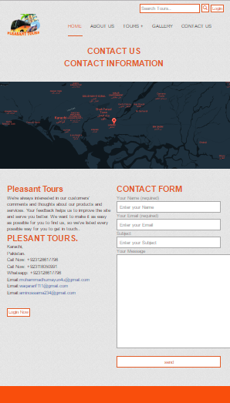

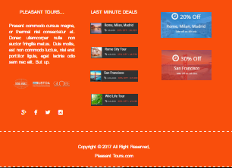

# STARTING OF “LOGIN PAGE”

<!DOCTYPE HTML>

<html>

<head>

<link rel="shortcut icon" href="img/favicon.ico">

<meta http-equiv="Content-Type" content="text/html; charset=utf-8">

<title>Login Form</title>

<style type="text/css">

body{

background:url(img/bgnoise_lg.png);

font:bold 12px Arial, Helvetica, sans-serif;

margin:0;

padding:0;

min-width:960px;

color:#bbbbbb;

}

a {

text-decoration:none;

color:#00c6ff;

}

h1 {

font: 4em normal Arial, Helvetica, sans-serif;

padding: 20px; margin: 0;

text-align:center;

}

h1 small{

font: 0.2em normal Arial, Helvetica, sans-serif;

text-transform:uppercase; letter-spacing: 0.2em; line-height: 5em;

display: block;

}

h2 {

color:#bbb;

font-size:3em;

text-align:center;

text-shadow:0 1px 3px #161616;

}

.container {width: 960px; margin: 0 auto; overflow: hidden;}

#content { float: left; width: 100%;}

.post { margin: 0 auto; padding-bottom: 50px; float: left; width: 960px; }

.btn-sign {

width:460px;

margin-bottom:20px;

margin:0 auto;

padding:20px;

border-radius:5px;

background: -moz-linear-gradient(center top, #00c6ff, #018eb6);

background: -webkit-gradient(linear, left top, left bottom, from(#00c6ff), to(#018eb6));

background: -o-linear-gradient(top, #00c6ff, #018eb6);

filter: progid:DXImageTransform.Microsoft.gradient(startColorStr='#00c6ff', EndColorStr='#018eb6');

text-align:center;

font-size:36px;

color:#fff;

text-transform:uppercase;

}

.btn-sign a { color:#fff; text-shadow:0 1px 2px #161616; }

#mask {

display: none;

background: #000;

position: fixed; left: 0; top: 0;

z-index: 10;

width: 100%; height: 100%;

opacity: 0.8;

z-index: 999;

}

.login-popup{

display:none;

background: #333;

padding: 10px;

border: 2px solid #ddd;

float: left;

font-size: 1.2em;

position: fixed;

top: 50%; left: 50%;

z-index: 99999;

box-shadow: 0px 0px 20px #999;

-moz-box-shadow: 0px 0px 20px #999; /* Firefox */

-webkit-box-shadow: 0px 0px 20px #999; /* Safari, Chrome */

border-radius:3px 3px 3px 3px;

-moz-border-radius: 3px; /* Firefox */

-webkit-border-radius: 3px; /* Safari, Chrome */

}

img.btn_close {

float: right;

margin: -28px -28px 0 0;

}

fieldset {

border:none;

}

form.signin .textbox label {

display:block;

padding-bottom:7px;

}

form.signin .textbox span {

display:block;

}

form.signin p, form.signin span {

color:#999;

font-size:11px;

line-height:18px;

}

form.signin .textbox input {

background:#666666;

border-bottom:1px solid #333;

border-left:1px solid #000;

border-right:1px solid #333;

border-top:1px solid #000;

color:#fff;

border-radius: 3px 3px 3px 3px;

-moz-border-radius: 3px;

-webkit-border-radius: 3px;

font:13px Arial, Helvetica, sans-serif;

padding:6px 6px 4px;

width:200px;

}

form.signin input:-moz-placeholder { color:#bbb; text-shadow:0 0 2px #000; }

form.signin input::-webkit-input-placeholder { color:#bbb; text-shadow:0 0 2px #000; }

.button {

background: -moz-linear-gradient(center top, #f3f3f3, #dddddd);

background: -webkit-gradient(linear, left top, left bottom, from(#f3f3f3), to(#dddddd));

background: -o-linear-gradient(top, #f3f3f3, #dddddd);

filter: progid:DXImageTransform.Microsoft.gradient(startColorStr='#f3f3f3', EndColorStr='#dddddd');

border-color:#000;

border-width:1px;

border-radius:4px 4px 4px 4px;

-moz-border-radius: 4px;

-webkit-border-radius: 4px;

color:#333;

cursor:pointer;

display:inline-block;

padding:6px 6px 4px;

margin-top:10px;

font:12px;

width:214px;

}

.button:hover { background:#ddd; }

</style>

<script type="text/javascript" src="js/jquery.min.js"></script>

<script type="text/javascript">

$(document).ready(function() {

$('a.login-window').click(function() {

// Getting the variable's value from a link

var loginBox = $(this).attr('href');

//Fade in the Popup and add close button

$(loginBox).fadeIn(300);

//Set the center alignment padding + border

var popMargTop = ($(loginBox).height() + 24) / 2;

var popMargLeft = ($(loginBox).width() + 24) / 2;

$(loginBox).css({

'margin-top' : -popMargTop,

'margin-left' : -popMargLeft

});

// Add the mask to body

$('body').append('<div id="mask"></div>');

$('#mask').fadeIn(300);

return false;

});

// When clicking on the button close or the mask layer the popup closed

$('a.close, #mask').live('click', function() {

$('#mask , .login-popup').fadeOut(300 , function() {

$('#mask').remove();

});

return false;

});

});

</script>

</head>

<body>

<div class="container">

<div id="content">

<div class="post"><br>

<br>

<br>

<br>

<br>

<br>

<div style="text-align:center;"><br>

<br>

<img src="img/logo.png" alt="image">

</div>

<h2>Login Form</h2>

<div class="btn-sign">

<a href="#login-box" class="login-window">Login</a>

</div>

</div>

<div id="login-box" class="login-popup">

<a href="#" class="close"><img src="images/close_pop.png" class="btn_close" title="Close Window" alt="Close" /></a>

<form method="post" class="signin" action="#">

<fieldset class="textbox">

<label class="username">

<span>Username or email</span>

<input id="username" name="username" value="" type="text" autocomplete="on" placeholder="Username">

</label>

<label class="password">

<span>Password</span>

<input id="password" name="password" value="" type="password" placeholder="Password">

</label>

<button class="submit button" type="button" onClick="login()">Login</button>

<p>

<a class="forgot" href="index.html">Forgot your password?</a>

</p>

</fieldset>

</form>

</div>

</div>

</div>

<script>

function login(){

var userName=document.getElementById('username').value;

var password=document.getElementById('password').value;

if(userName=="mohammadhumayun4u@gmail.com"&&password=="123"){

location.href = 'humayun.html';

}

else if(userName=="waqararif111@gmail.com"&&password=="123"){

location.href = 'waqar.html';

}

else if(userName=="aminosama234@gmail.com"&&password=="123"){

location.href = 'osama.html';

}

else{

alert("Login was unsuccessful");

}

}

</script>

</body>

</html>

***END OF “LOGIN PAGE”***

# SCREEN SHOT OF “LOGIN PAGE”

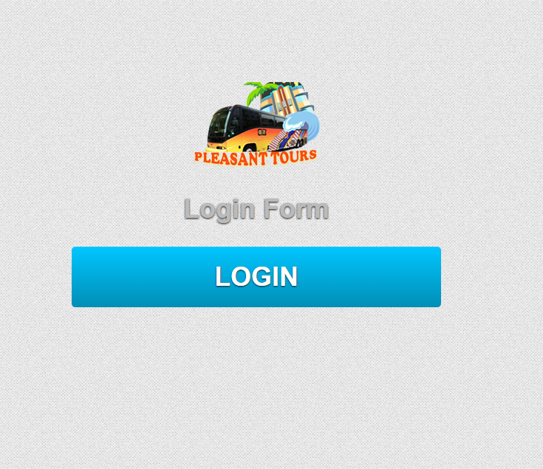

# STARTING OF “LOGIN SUB PAGE 1”

<!doctype html>

<html>

<head>

<meta charset="utf-8">

<link rel="shortcut icon" href="img/favicon.ico">

<title>Mohammad Humayun</title>

<link rel="stylesheet" href="css/main_style.css">

<link rel="stylesheet" href="css/bootstrap.min.css">

</head>

<body class="loginbody">

<div class="container text-center">

<div class="row">

<div class="col-md-12">

<a href="index.html">

<img src="img/logo.png" alt="image">

</a>

</div>

</div>

<div class="row">

<div class="col-md-12">

<h1 class="log-h">Welcome Mohammad Humayun</h1>

</div>

</div>

<div class="row">

<div class="col-md-12"><br>

<br>

<br>

<br>

<img class="log-im" src="img/humayun.jpg" alt="Mohammad Humayun">

</div>

</div><br>

<br>

<br>

<a href="e project report/E-Project Report.docx" class="tour-btn">Download E-project Report</a>

<br>

<br><br>

<a href="https://www.facebook.com/rao.humayunali?fref=ts" target="_blank">

<img src="img/facebook.png" alt="image" style="height:50px;width:50px;">

</a>

</div>

</body>

</html>

***END OF “LOGIN SUB PAGE 1”***

# SCREEN SHOT OF “LOGIN SUB PAGE 1”

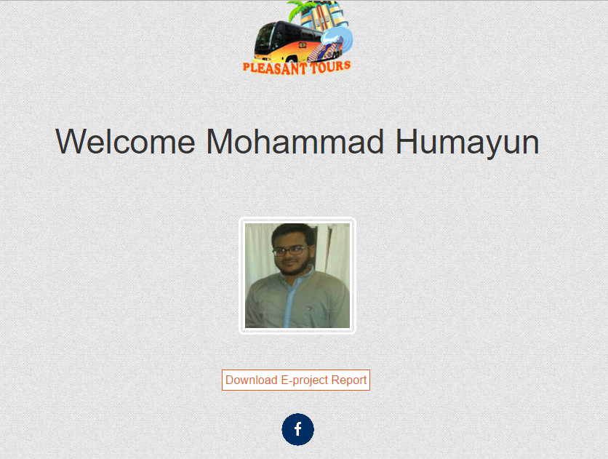

# STARTING OF “LOGIN SUB PAGE 2”

<!doctype html>

<html>

<head>

<link rel="shortcut icon" href="img/favicon.ico">

<meta charset="utf-8">

<title>Mohammad Humayun</title>

<link rel="stylesheet" href="css/main_style.css">

<link rel="stylesheet" href="css/bootstrap.min.css">

</head>

<body class="loginbody">

<div class="container text-center">

<div class="row">

<div class="col-md-12">

<a href="index.html">

<img src="img/logo.png" alt="image">

</a>

</div>

</div>

<div class="row">

<div class="col-md-12">

<h1 class="log-h">Welcome Waqar Arif</h1>

</div>

</div>

<div class="row">

<div class="col-md-12"><br>

<br>

<br>

<br>

<img class="log-im" src="img/waqar.jpg" alt="Mohammad Humayun">

</div>

</div><br>

<br>

<br>

<a href="e project report/E-Project Report.docx" class="tour-btn">Download E-project Report</a>

<br>

<br><br>

<a href="https://www.facebook.com/profile.php?id=100007155885737&fref=ts" target="_blank">

<img src="img/facebook.png" alt="image" style="height:50px;width:50px;">

</a>

</div>

</body>

</html>

# END OF “LOGIN SUB PAGE 2”

SCREEN SHOT OF “LOGIN SUB PAGE2”

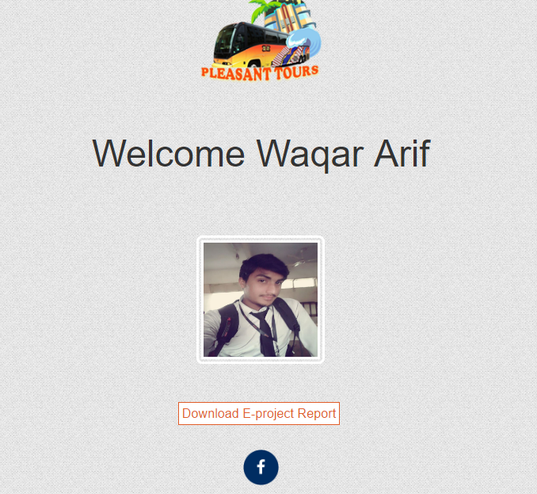

# STARTING OF “LOGIN SUB PAGE 3”

**<!doctype html>**

**<html>**

**<head>**

**<meta charset="utf-8">**

**<link rel="shortcut icon" href="img/favicon.ico">**

**<title>Mohammad Humayun</title>**

**<link rel="stylesheet" href="css/main_style.css">**

**<link rel="stylesheet" href="css/bootstrap.min.css">**

**</head>**

**<body class="loginbody">**

**<div class="container text-center">**

**<div class="row">**

**<div class="col-md-12">**

**<a href="index.html">**

**<img src="img/logo.png" alt="image">**

**</a>**

**</div>**

**</div>**

**<div class="row">**

**<div class="col-md-12">**

**<h1 class="log-h">Welcome Osama Amin</h1>**

**</div>**

**</div>**

**<div class="row">**

**<div class="col-md-12"><br>**

**<br>**

**<br>**

**<br>**

**<img class="log-im" src="img/osama.jpg" alt="Mohammad Humayun">**

**</div>**

**</div><br>**

**<br>**

**<br>**

**<a href="e project report/E-Project Report.docx" class="tour-btn">Download E-project Report</a>**

**<br>**

**<br><br>**

**<a href="https://www.facebook.com/rao.humayunali?fref=ts" target="_blank">**

**<img src="img/facebook.png" alt="image" style="height:50px;width:50px;">**

**</a>**

**</div>**

**</body>**

**</html>**

***END OF “LOGIN SUB PAGE 3”***

# SCREEN SHOT OF “LOGIN SUB PAGE 3”



